**1. INTRODUCTION**

The pet and poultry industries play a big part in satisfying the demands of pets and poultry, from pet owners looking for high-quality products for the customer’s beloved pets to farmers and breeders needing necessary supplies for poultry. In this chapter, the general idea of the project, business background, current process, business challenges encountered, the cause and effect of the business manual process, solution, and the development of the project are discussed.

**1.1 Project Context**

The pet market has grown significantly in recent years as more individuals accept dogs as beloved family members. Due to the increase in pet ownership, there has been a dramatic increase in demand for pet supplies, which has resulted in a considerable change in consumer preferences for pet shopping.

One of the emerging shops and high-demand customers is Mrs. Remedios Santiago and her family owns R De Leon Poultry Supplies, these pets, and poultry supplies. The store was established on October 28, 2019, it was in Paso, Bagbaguin, Sta. Maria, Bulacan. The store experienced the most change in the last four years due to an unexpected increase in customer demand. The business has one branch, and it is in Pulong, Buhangin, Santa Maria, Bulacan. The pet supply shop has a total of five (5) employees, including the three owners and two regular employees.

The R De Leon Poultry Supplies is open from 8:00 am to 6:00 pm, Monday through Sunday. There are more than 400 different products, according to the store's list of available goods. The shop sells items for pets and poultry, including feeds, dog food, personal care items, dog and chicken accessories, common medications for poultry, and other related items.

Due to the placement on a commercial site, which is highly profitable, the business has a large customer base and offers reasonable prices without sacrificing the quality of its goods. According to the owner, the estimated number of customers that purchased in the store is an average of 100 to 300 customers per day. The store offers affordable prices without compromising the quality of the products.

Currently, the store uses a traditional system to record the sales and other transactions, which is done through a record book. For payment, the poultry supplies only accept cash from the customers. R De Leon Poultry Supplies issues two types of receipts, the registered receipt is used for BIR purposes, a private company, and government purchase. The other receipt is unregistered and does not have a business name.

The customer will ask the cashier if the product that the buyer wishes to purchase is in stock when the customer visits R De Leon Poultry Supplies' physical location to begin the transaction. The customer can also inquire about the product's location, price, and other information from the employee in charge. Once the item has been obtained, the buyer will proceed to the counter to present the item and the payment to the cashier. After placing the items on the counter, the cashier lists each item and its price on a piece of paper, and then manually calculates the total. The cashier will ask for payment from the customer before providing an unregistered receipt and any necessary change. The store offers discounts for selected items when the customer buys a lot and, the owner also gives a discount to acquaintances who often buy from the store.

Customers must provide the receipt received on that day when the buyer wants to return things that the customer purchased from the store. R De Leon Poultry Supplies has a 7-day replacement policy, which means the customer has 7 days after purchasing the item to request a return. To meet the requirements, the customer must present a receipt, the product must be in good condition and the customer must have valid reasons for returning the item, any product can be returned except vaccines, which cannot be returned to a store because of the risk of losing the temperature control, becoming contaminated, and failing to meet regulatory requirements.

The owner of the R De Leon Poultry Supplies has a delivery every day except for holidays. To get another supply, the owner has a contact person to send a message or dial for the next batch of orders. The supplier will confirm all the ordered products from the customer. After that, the supplier will issue a receipt, then the supplier will deliver it to the store or the owner of the R De Leon Poultry Supplies can pick up the items. For stock inventory the Poultry Supplies Shop conducts inventory every day to ensure that the product stays on top of the stock levels and promptly replenishes items when the product reaches critical or minimum inventory levels, the owner usually buys an item if the stock is at a critical level or if the product reaches the minimum inventory level. For medicine, the critical level is 5 boxes/bottles/packs depending on the specific item, for Feeds, Cat food, and Dog foods, the critical level is 4 sacks per brand. If the stocks reach the minimum stock level, the Staff/Cashier will inform the owner, and the owner will order stocks from the supplier. To record the item received from the supplier, the owner or the employee will write it in the record book and keep the supplier’s invoice for inventory and price reference.

This is one of the issues the business wants to solve, since not all transactions, especially those involving customers who received discounts, are recorded when tallying sales in the record book, the current sales and actual sales in a day can be different. Here, mistakes might happen all the time. The store's typical method for keeping track of sales and listing defective items consists of a hardbound book, a pen, and correction tape. When it comes to examining this thing, the owner or the employee merely glances at the papers provided by the supplier and then immediately displays the information in the store. All the items received from the supplier are stored on paper.

The outdated method can be affects for today's generation since errors might occur in the future. Modern business owners use cutting-edge software to ensure that the records are correct and current. Such a system can change data to preserve it. However, there will be a cost associated with installing the software or application on the device because it requires a financial investment in an already successful business. As a result, a record book won't be the main source of information on sales and inventories anymore. In circumstances unrelated to how sales are calculated mathematically, it might only be temporarily essential.

R De Leon Poultry Supplies encountered transactional difficulties during the pandemic as many clients were unable to leave the house to make purchases. The store is still seeing more customers, despite the pandemic steadily fading away. One of the store's owners, Mr. Freddie Mark Santiago, stated in an interview that the owner now gets orders from consumers who live far away. However, when the Poultry Supplies Shop gets a lot of orders, managing transactions might be difficult. The store will receive the order/s from the customer through Facebook messenger and after that, the staff or the cashier's responsibility is to confirm the order, and the owner will deliver it to the customer if the location is near, or it can be delivered using other delivery services such as LBC. For the customer, there were considerations, if the buyer always buys at the store and is already known by the owner, the shop will allow Cash on Delivery (COD) as the mode of payment. However, if a customer places the first order with the shop, the store requires payment first before the delivery of the product. The staff/cashier started to collect the payment through cash or E-wallet payment (G-cash) from the customer.

The R De Leon Poultry Supplies use the manual approach in the transaction process, it takes time to list down all the items purchased, the time to compute all the items, and the total change that will be given to the customer. Next is the sales and inventory, in which the owner cannot track the sales accurately and the reports are not precise to the sales and stock counts. In addition to the process the checking the stock count available in the store, it is also time-consuming to check every container or the boxes of the products to ensure the available items. Lastly is online ordering, the owner finds it difficult to accommodate all the online purchasers since the shop uses a manual process.

The manual method can have an impact on the current business given all the issues and challenges the business owner must deal with. Since everything is recorded in a logbook, there will be no automatic updating of the sales, inventory, or reports for a while, and everything will need to be recorded by hand. The business will be affected if something happens to the logbook, and it is challenging to extract all the information that was entered into it.

The proponents proposed a system that allows customers to obtain pet and poultry supplies online to address this issue. To make purchases from the business, the customer might be able to set up an account. Once a customer creates an account and successfully logs in, the buyer may choose what items the customer wishes to buy and have them delivered to the selected address. The system may gather the customer's name and address among other basic data. After the data has been correctly entered, the customer can choose the preferred payment option. In the system, there are two different payment methods: g-cash and cash on delivery. Furthermore, the proponents are aware that certain consumers might feel more at ease shopping in person rather than online.

To improve the current process, the proponents designed a project Ordering and Billing System with Point of Sales for R De Leon Poultry Supplies. The system can be of great help to manage and keep track of the inventory, speed up purchase transactions with quicker responses for better customer service, and eliminate human error for more accurate data. A Point of Sale (POS) system was created by the proponents to facilitate rapid and simple sales transactions in physical establishments.

Customers may easily buy things with this system, and employees can quickly record purchases and update inventory. The purchasing procedure is seamless for customers as well as employees because of the POS system's user-friendliness and automatic receipt generation. The ordering and billing system will serve as the online website that can be used by the customer, to browse and order poultry supplies online. The website will benefit the owner and the buyers to have a clear and safe online transaction.

It is significantly more efficient and convenient to use the corresponding software and application system on a device instead of manually listing the sales. Additionally, the proponents maintain the items that have been kept for record-keeping purposes in a database like MySQL.

**1.2 Objectives of the Study**

*1.2.1 General Objective*

The general objective of the study is to develop an Online Ordering and Billing System with a Point of Sales for R De Leon Poultry Supplies, that can help in processing customer orders and improve inventory management.

*1.2.2 Specific Objectives*

The study aims:

1. To develop a system that can produce an accurate transaction record, sales transactions, and an error-free recording system.

2. To design a simple user interface that enables users to browse products, verify product availability, add things to their carts, and safely complete payments.

3. To develop a system that can manage the inventory, reduce stock-outs, minimize the wastage of products, can generate, and analyze sales reports.

4. To develop an online ordering system that can be used by the customer to make a transaction easily.

5. To conduct alpha and beta testing to validate if the system and functionalities meet the requirements.

6. Evaluate the system's acceptability using ISO-9126-1

**1.3 Purpose and Description**

In general, the purpose of our study is to develop an online ordering and billing system with a point of sale to improve the ordering process of R De Leon Poultry Supplies and enhance the sales and inventory management processes. Our goal is to enhance the customer experience and increase efficiency for R De Leon Poultry Supplies.

*1.3.1 Owner*

The study will help the owner to manage inventory, track sales, improve profitability, and reduce financial losses by streamlining sales and inventory management processes, generating sales reports, accurately documenting sales, and inventory transactions, and providing flexibility in managing the store.

*1.3.2 Poultry Supplies Shop*

The study will help the store to have accurate daily weekly and monthly sales and inventory reports with the help of the system.

*1.3.3 Staff/Cashier*

The study will help the staff/cashiers manage daily sales transactions and perform the employee’s duties more efficiently and accurately, providing a better customer experience and improving the overall performance of the store.

*1.3.4 Customer*

The study will help the customer to provide convenient and safe options for customers to purchase products either from home or in-store using the point-of-sale system, which makes the purchase process efficient and generates automatic receipts.

*1.3.5 Delivery Personnel*

The study will streamline delivery operations by providing efficient order processing, tracking of deliveries, and optimizing routes for timely and effective distribution of products to customers.

*1.3.6 Proponents*

The study will help the proponents to finish the given tasks needed for the completion of the Case Study project by applying the knowledge that the proponents gained from conducting an interview and researching for additional information.

*1.3.7 Future Proponents*

The system can serve as a model and guide for future proponents who want to develop similar systems, inspire future proponents to integrate new and innovative features, and serve as a template for other businesses that want to improve the sales and inventory management processes.

**1.4 Scope and Delimitation**

The system will focus on the design and development of a web-based Ordering and billing System with a Point of Sales for R. De Leon Poultry Supplies.

The system is structured to offer different levels of access and permissions to users based on roles such as System Administrators, Staff/Cashiers, Delivery personnel, and Customers. The System Administrator holds the highest authority, with the ability to manage user accounts, including creating, modifying, or archiving staff/cashier and delivery personnel accounts. Additionally, the System Administrator is responsible for distinguishing between active and inactive accounts. When it comes to inventory management, only the System Administrator can update, add, or archive items.

The system excels in generating various reports, notably Sales and Inventory reports, providing detailed insights into sales, revenue, order volumes, and performance metrics. A noteworthy feature is the system's capacity to export these reports into Excel, enhancing usability. System Administrators also have control over the Point of Sale (POS), allowing the administrator to update system information and monitor orders. Staff/Cashiers are granted access to the POS functionality, enabling the employee to conduct transactions and update the account information. Delivery personnel, responsible for managing order fulfillment, can update delivery statuses and maintain the account details.

Customers, as end-users, can create and manage accounts, giving the buyers control over orders and billing. The system incorporates an audit trail for security purposes, keeping a detailed record of user activities within the system. This audit trail can be sorted by date and user, providing transparency and accountability in user interactions. In summary, the system's accessible features and well-thought-out functionalities cater to diverse roles, ensuring efficiency and security in user interactions.

The website incorporates fundamental account management features, commencing with account registration and login functionalities. During the registration process, customers are required to provide essential information, including First name, Last name, address, email address, Contact number, Username, and Password. Notably, customer registration mandates agreement with the privacy policy. Post-registration, an email verification is triggered. Upon successful verification, customers gain access to the accounts using a designated username and password.

Users enjoy autonomy in managing and updating the contact information, shipping addresses, and other pertinent details. The system offers a comprehensive product catalog, presenting an array of products and services with associated details such as product/service information, price, and availability. Customers are further empowered with order management capabilities, enabling the buyers to place, modify, and track orders.

Additionally, customers can view the order history and stay informed about order status updates. Privileges extend to discounts and order_discount_s, which customers can readily view and avail of within the system. To facilitate secure transactions, the payment processing feature provides options such as cash on delivery (COD) or E-wallet (G-cash).

The system incorporates a robust mechanism for returns or refunds, allowing customers to initiate the process by selecting either option and providing relevant details, including photos of the product and a receipt. Notably, customers have a seven-day window from the date of purchase to request a return or refund. Subsequently, the system administrator assumes a crucial role in checking and inspecting the validity of returned items. Approval from the system administrator is a prerequisite for the processing of the return or refund, ensuring a judicious and secure handling of customer requests.

The Staff/Cashier has access to both the Point of Sale (POS) system and the Online ordering module on the website, necessitating the input of a username and password for login. The website incorporates a dedicated POS module designed for customers making direct purchases from the store. In this process, the Staff/Cashier inputs the product name or product code for each item the customer is purchasing.

Upon completion, the system automatically computes the total amount. Subsequently, the Staff/Cashier inputs the amount received from the customer, and the system calculates the change owed. To finalize the transaction, the Staff/Cashier initiates the printing of the receipt generated by the system. This straightforward process ensures a streamlined and efficient method for handling in-store transactions, providing both the staff and customers with a user-friendly experience.

For walk-in transactions, customers inquire with the cashier about product availability. The Staff/Cashier then utilizes the system to search for the product by name or code, determining its availability for the customer. This allows for prompt communication with the customer regarding the product's availability.

In the case of online transactions, customers can browse the product catalog to verify product availability before placing an order. Before order placement, customers are required to log in to the site. This login step serves as a checkpoint for customers to review and confirm the preferred product selection.

Additionally, customers retain the flexibility to cancel orders and monitor the order status. The order approval process rests with the Owner, who reviews and approves customer orders. Once approved, the Owner assumes the responsibility of order monitoring. Subsequently, the delivery personnel are tasked with delivering the approved order to the customer's specified address. The delivery personnel also hold the authority to cancel customer orders, adding a layer of flexibility to the order fulfillment process. This structured approach ensures a systematic and transparent handling of both walk-in and online transactions within the system.

In the context of Online ordering, the Staff/Cashier is equipped with the capability to review the available supplies through the system. The product list comprises essential details such as item descriptions, product availability, and pricing. A noteworthy feature includes a discount function, allowing the Owner to set specific discounts on items. Customers can also enjoy discounts when purchasing in larger quantities. Additionally, the system facilitates the printing of receipts, ensuring a comprehensive transaction record.

To streamline the order process, the system has a search function enabling the Staff/Cashier to check the availability of products. Upon receiving orders from customers, the Staff/Cashier can access the order details, verifying the product's availability. Once confirmed, the Staff/Cashier proceeds to process the order. Effective communication is established with the delivery personnel through the website, providing vital information about the customer's order. This information encompasses details such as the product ordered, shipping address, and payment specifics.

The delivery personnel are further empowered to update the order status, transitioning through stages such as preparing, in-transit, and delivery. This real-time update mechanism ensures both customers and staff are well-informed about the order's progress. Moreover, the delivery personnel can manage and update personal information through the website, adding a layer of convenience and efficiency to the role within the system. Overall, these features contribute to a streamlined and efficient online ordering process, promoting transparency and ease of use for both staff and customers.

The optimal performance of the website is achieved when viewed using the Chrome browser and operating on the Windows 10 operating system. While it is designed to function optimally on Windows 10, efforts have been made to ensure compatibility with Windows 7 and Windows 8 as well. The website's development framework encompasses HTML and Bootstrap for frontend development, PHP for backend functionality, and MySQL Server as the database, ensuring a robust and dynamic platform.

To guarantee a seamless experience, a minimum internet speed of 3mbps is recommended for efficient updating of both online and local databases. For accessibility on smartphones, the website is designed to operate on devices with a minimum of 256MB of Random Access Memory (RAM). iOS users can access the website with an iPhone 4s or later, while Android users are required to have a minimum operating system of Android 5.0 (Lollipop) or later. These specifications collectively contribute to an optimized user experience, ensuring compatibility across various devices and operating systems while maintaining a responsive and efficient performance.

**2. REVIEW OF RELATED LITERATURE AND RELATED STUDIES**

This chapter covers related literature and related systems related to the system. A conceptual framework for the study and definition of terms are also included.

**2.1 Review of Related Literature and Studies**

One of the important factors for most businesses is order management. Order management has a direct impact on how a customer perceives a business or brand. Order management starts when a customer places an order and ends once they receive their package or service. It allows a business to coordinate the fulfillment process from order collection, inventory, and delivery visibility to service availability [16]. Effective order management requires fulfilling orders without overwhelming the business’s capacity [21].

Along with Order management is inventory. The term inventory refers to the raw materials used in production as well as the goods produced that are available for sale. A company's inventory represents one of the most important assets it has because the turnover of the inventory represents one of the primary sources of revenue generation and subsequent earnings for the company's shareholders. There are three types of inventories, including raw materials, work-in-progress, and finished goods. It is categorized as a current asset on a company's balance sheet [14]. In today’s competitive business landscape, timely and effective billing is more important than ever. It not only ensures that revenue is collected promptly, but also enhances the customer experience by providing clear and transparent billing information. In accounting, billing is a crucial component of the revenue cycle and a key factor in ensuring business success. It involves creating and sending invoices that are clear, concise, and professional to customers or clients, to generate revenue [20].

According to a study conducted by the National Restaurant Association, more than 60% of consumers ordered food for delivery or takeout at least once a week during the pandemic. This shift in consumer behavior has made it critical for businesses to have an ordering and billing system in place [20]. This been suggested that restaurants with online ordering and billing systems had better survival rates during the pandemic. One benefit of ordering and billing systems is that they allow businesses to streamline their operations. By automating the ordering and billing process, businesses can reduce the workload on their staff, who may be working remotely or on reduced hours. This can help businesses save money on labor costs and ensure that orders are processed quickly and accurately [5].

Another benefit of ordering and billing systems is that they can improve the customer experience. With an online ordering system, customers can place orders from the comfort of their own homes and avoid long lines and wait times. Billing systems that accept multiple payment methods can also make it easier for customers to pay for their orders, which can lead to increased customer satisfaction and loyalty. However, implementing an ordering and billing system can also have its challenges. Businesses may face technical issues and high costs when implementing an ordering and billing system. Furthermore, businesses must ensure that their ordering and billing system is secure and comply with data protection laws [10].

Having an e-commerce website for online shopping has become a commonplace practice. Most e-commerce systems use similar techniques for project development. While some may incorporate additional techniques to enhance the popularity of their websites, the primary product-selling system is generally the same across all platforms. Considering this, we have developed our project using a customized technique after a thorough study of standard online shopping systems. An extensive literature review of online shopping behavior explores various factors that influence the decision-making process, including convenience, cost, trust, ease of use, and customer service. Additionally, the review delves into the significance of social media for online shoppers [24].

Despite the store having an online ordering system, hands-on transactions are still preferred by customers who prefer physical shopping. Point of sale (POS) systems are an essential tool for modern businesses. They help streamline operations, improve accuracy, and provide real-time data that businesses can use to make informed decisions [23]. However, POS systems also offer many benefits to traditional or manual systems that businesses have used for years.

POS systems can automate many manual processes such as inventory management, sales tracking, and financial reporting. This reduces the need for manual data entry and frees up time for employees to focus on other tasks. For example, instead of manually counting inventory, a POS system can track stock levels automatically, alerting employees when stock levels are low and reordering products when necessary. By automating these processes, businesses can improve efficiency and reduce the risk of errors. POS systems can improve accuracy by automating data entry and reducing the risk of mistakes. Manual systems are prone to errors due to human error, but POS systems can improve accuracy by automating data entry and reducing the risk of mistakes. For example, a POS system can automatically record sales and inventory data, reducing the risk of errors that can occur with manual data entry. This not only helps to improve accuracy but also saves time and resources by eliminating the need for manual data entry. POS systems can enhance customer service by making it easier and faster for employees to process transactions, answer questions, and provide information. By using a POS system, employees can quickly process transactions, accept different payment methods, and provide detailed receipts to customers. This not only speeds up the checkout process but also improves the customer experience by providing accurate and timely information. Additionally, POS systems can help businesses personalize the customer experience by providing real-time data on customer behavior and preferences, allowing businesses to tailor promotions and offers to individual customers [23].

Based on the conducted survey the top 5 high scores for editors score are Clover, Toast, Lightspeed, Touch Bistro, and Go Daddy. Clover got a high score of 89/100 with the best use case for hardware, they offer a 30-day free trial and support over 100+ integrations [13]. Clover is a comprehensive point-of-sale (POS) system that enables business owners to manage their operations from any location. With the Clover Go application, you can effortlessly generate orders, process payments, and send receipts to your customers via text message. Additionally, the system allows you to view a detailed record of all your transactions at the end of the business day.

In a restaurant, customers waiting to be served can be a common occurrence. However, this aspect is often overlooked by restaurant owners, which can result in customers choosing to go to a competitor. Taste, ambiance, and service are important factors that contribute to a restaurant's success. When these factors are carefully managed, an establishment can attract a substantial number of customers. In fast food restaurants, fast service is particularly crucial to prevent customers from leaving due to long delays in line, especially during mealtimes when customers are looking for a quick meal. To address this issue, this research aimed to develop a mobile ordering application for a fast-food restaurant that offers a range of functionalities for customers to order food through the platform. The system was developed using the Agile Methodology to ensure proper implementation. A survey was conducted to assess the acceptability of the mobile application, involving five small fast food and restaurant owners as well as fifty prospective customers. The survey results indicated that the expected acceptability rating was achieved. Although some improvements to the system were recommended, they were not implemented in the current version due to time constraints and their non-applicability to the current study [11].

Customer preferences and expectations when using online ordering systems with POS are crucial factors in determining overall customer satisfaction. Ease of use, convenience, and personalization options are important considerations for customers when using online ordering systems. Customers expect a user-friendly interface that allows for seamless navigation, quick order placement, and customization options to suit their preferences. Convenience is also a significant factor, as customers appreciate the ability to place orders from the comfort of their own homes or on the go. Additionally, factors such as order accuracy, order tracking, and timely delivery or pickup are critical in ensuring customer satisfaction with online ordering. Customers expect their orders to be accurate, delivered, or ready for pick up on time, and the ability to track their orders in real-time. Customer feedback on their experiences with online ordering systems integrated with POS, including customer reviews, surveys, and testimonials, can provide valuable insights into the strengths and weaknesses of the system and help restaurants make improvements to enhance customer satisfaction.[25]

QMS (Quality Management System) is a management philosophy gaining importance in today's competitive markets. Researchers conducted a quantitative study in a Philippine government corporation to determine the impact of QMS practices on business performance. Results revealed significant positive impacts of QMS practices on various business performance perspectives. This is particularly relevant for government corporations, which operate as both public sector and business entities. The findings highlight the importance of delivering quality-oriented government services to the Filipino people.[22]

Paperless billing provides businesses with a modern and efficient way to receive payments securely, eliminating the need for paper bills and check payments [17]. This digital approach enables online bill delivery and payment processing, leading to improved efficiency and cost reduction. To implement paperless billing, businesses integrate multiple systems such as billing systems, banking platforms, customer payment systems, and an online interface. This method is particularly advantageous for businesses that have recurring billing cycles. By offering electronic bill delivery options, such as PDF documents or online portals, customers have the convenience of reviewing their bills before submitting payments.

The advent of Information and Communication Technology (ICT) and digital innovation has brought about significant changes in the business landscape. As a result, there has been a notable shift from cash-based transactions to electronic-based transactions. It is important to note that the introduction of the e-payment system was not intended to replace cash entirely but rather to provide a more convenient alternative to cash and trade barter. Electronic payments refer to a payment mechanism that utilizes electronic media instead of physical currency. The e-payment system plays a crucial role in the realm of e-commerce. the study of Fatohna aims to examine existing literature on e-payment systems in e-commerce, explore the scope of the e-payment system, and review the methodologies employed by previous researchers. The intention is to identify research gaps and make recommendations for future studies in this field [7]. The payment system will help customers to have faster and easier transactions to place an order.

The proponents also develop a delivery system that will help customers to place an order online. The delivery process can involve various methods, including parcels or different types of packaging, to ensure that customers receive their orders in the precise condition they were requested. Payment for the delivered goods can be made either before or after the delivery takes place [1]. Employing this system to fulfill orders simplifies purchasing and selling while fostering trust between customers and sellers. Online mediums excel in terms of efficiency compared to the traditional manual system of product delivery, thus further enhancing the relationship between customers and sellers.

PHP is highly popular among programmers and web developers, with approximately 79.2% of websites utilizing it in some capacity. It is widely employed by major online platforms such as Facebook, Wikipedia, WordPress, and Zoom. Understanding how PHP can enhance website development is crucial. Let's delve into its benefits in more detail [27]. The proponents use PHP as a programming language choice to build the RDPOS system. PHP is a dynamically typed language that utilizes eight data types to define variables, which can store various types of data. Unlike many other programming languages, PHP is flexible in its treatment of variables, as it automatically evaluates and infers their data types. Variable names in PHP begin with a dollar sign ($) but can be chosen freely if they start with a letter [27].

In addition, the proponents use HTML, CSS, and Bootstrap to build the entire front-end design of the RDPOS websites. HTML, which stands for Hypertext Markup Language, and CSS, which stands for Cascading Style Sheets, are fundamental technologies used to construct web pages. HTML is responsible for defining the structure of the page, while CSS controls the visual and auditory layout of the content, adapting it for various devices. CSS, known as Cascading Style Sheets, is a language utilized to define the visual aspects of web pages, encompassing elements like colors, layouts, and fonts. It provides the flexibility to tailor the presentation to various device types, such as large screens, small screens, or printers. CSS operates independently of HTML and can be applied alongside any XML-based markup language [29].

Furthermore, the proponents used Bootstrap to enhance front-end design and to have an efficient and fast layout of the website. Bootstrap as a web development enables developers to focus on the coding aspect without being concerned about the design, allowing them to quickly create visually appealing websites. On the other hand, it provides web designers with a robust framework to build captivating Bootstrap themes as a foundation. Bootstrap is a robust toolkit that comprises a set of HTML, CSS, and JavaScript tools designed for the creation and development of web pages and applications. It is a freely available open-source project hosted on GitHub, initially developed by and for Twitter [8].

MySQL stands out as a prominent technology within the contemporary big data ecosystem. Regarded as one of the most widely used databases, it is extensively employed across various industries, highlighting the importance for individuals involved in enterprise data or general IT to possess a basic understanding of MySQL [28]. This database used the proponents to save all data that will be gathered in the systems. These include accounts, orders, and deliveries.

To deploy the entire system the proponents used Hostinger as a reliable web server for the deployment of websites. Hostinger has gained recognition as a popular hosting provider, offering a range of features and services to facilitate efficient website management. This review examines the key advantages, performance metrics, and customer experiences associated with Hostinger, highlighting its effectiveness in meeting the requirements of website deployment. Additionally, it investigates the various hosting plans offered by Hostinger and their suitability for different types of websites. The findings of this review emphasize the importance of Hostinger as a trusted web server, providing users with a reliable platform for the successful deployment of their websites [6].

In the waterfall model, each stage must be completed entirely before moving on to the next one. Following the completion of each stage, a review is conducted to ensure alignment with the requirements established in the initial step. Essentially, this model operates sequentially, and its effectiveness is contingent on having clearly defined specifications that are well comprehended by all involved parties. Traditional software development methods revolve around four key stages: specification formation, design, construction, and testing. It is important to note that intermediate steps may still be present within this technique for software development [18]. The proponents used the modified waterfall model to develop the website for R de Leon Poultry Supply.

To develop a system, a computer is a must. Laptop and desktop computers are very similar. The proponents have the same basic hardware, software, and operating systems. The primary difference is how their components fit together. A Laptop is much smaller and lighter than even the most compact PC tower. Its screen is an integrated part of the unit, as is its keyboard. Instead of a spacious case with lots of room for air circulation, a laptop uses a small, flat design in which all the pieces fit together snugly. A desktop computer includes a motherboard, video card, hard drive, and other components in a large case. The monitor, keyboard, and other peripherals connect wirelessly or with cables. Whether the case sits vertically or horizontally, it has lots of space for add-in cards, cables, and air circulation [33].

System development requires a reliable network. LAN stands for local area network. A LAN is a group of computers and devices in a specific location. LANs were first used by colleges and universities in the 1960s. These computer networks were used to catalog library collections, schedule classes, record student grades, and share equipment resources [31]. A router typically connects physically, using a network cable, to the modem via the internet or WAN port and then physically, again through a network cable, to the network interface card in whatever wired network devices you have.

A wireless router can connect using various wireless standards to devices that also support the standard used [2]. Microsoft has made a big effort with Edge to improve the browsing experience, and it's paid off. Microsoft Edge has enough features and benefits that it's a real alternative to more popular browsers like Chrome or Firefox [12]. Microsoft Windows (also known as Windows or Win) is a graphical operating system developed and published by Microsoft. It provides a way to store files, run software, play games, watch videos, and connect to the Internet [30].

Agile methodologies have made significant contributions to the field of Software Engineering. This study introduces a novel approach to Software Requirements Specification, incorporating Agile principles into regulated environments such as aviation, medical, nuclear, and automotive industries. Software in Regulated Environments (SRE) entails a blend of plan-driven methods with essential documentation to ensure safety, reliability, security, and discipline [32]. The proposed framework seeks to strike a balance between agile and plan-driven methodologies, specifically focusing on Requirements Engineering. This encompasses activities related to the management, elicitation, documentation, and maintenance of requirements.

Software quality completely depends on various phases of SDLC. When we refer to the term “Software quality” it means well-analyzed and completely defined software according to the user requirements. The different phases of SDLC play a vital role in software development. The selection of the correct model and implementation of all its attributes is the basis for any good quality software. Several studies and models have been proposed to check the quality of good software. The objective of this paper is to present a review of the role of the analysis phase of SDLC for small-scale business applications [15]. And the reasons why small-scale businesses are not trying to accept software in their business practice. During the review process, we found analysis phase is the most important phase which is the base factor of any good quality-based software used by small, medium, or large-scale business applications.

This paper introduces a novel approach to validate object-oriented software during the design phase of project development. While various modeling diagrams are commonly employed in the Software Development Life Cycle's design phase, our focus in this study is on the UML Activity Diagram [3]. Our methodology involves initially constructing the UML activity diagram for the designated system using ArgoUML. Subsequently, we generate XML ("Extensible Markup Language") code from the constructed activity diagram. This XML code is then transformed into XSD ("XML Schema Definition") code. Using JAXB ("Java Architecture for XML Binding"), we generate a Java template from the XSD code, which is further refined into a complete Java program with minimal manual intervention.

The Software Development Life Cycle (SDLC) is a framework outlining the steps involved in software development at each phase [19]. It encompasses a detailed plan for constructing, deploying, and maintaining the software. The Implementation/Coding stage commences once the developer receives the Design document. The software's design is translated into source code, with all module components being implemented in this phase. The characteristics of this Implementation/Coding stage are evaluated using the Intuitionistic Analytical Hierarchy Process to determine the ranking or preference of the coding modules. The attributes utilized in this analysis are derived from data collected from experts in the field of software engineering.

The library holds a crucial role within academic institutions, and with the advent of Information and Communications Technology (ICT), there is a widespread effort across various sectors to automate their processes, including libraries. Technological advancements have significantly influenced and enhanced library operations. Nowadays, libraries seek innovative tools to boost productivity and enhance user services without the need for additional staff. The integration of Bar-code technology in libraries serves as an effective means to expedite client requests. This technology is primarily employed in the library's circulation system and has proven to be highly successful, thanks to its speed, accuracy, and reliability. Despite being a somewhat older technology, barcoding represents a noteworthy stride in library automation, yet its adoption in libraries is not yet widespread [5].

A thermal printer is a type of printer that uses a heated print head against a surface to create black text or images [4]. The heat from the print head activates special chemically treated paper (called thermal paper) or transfers solid ink from a ribbon, sticking it to the surface. The process varies depending on the type of thermal printer. These printers are commonly used for making labels, receipts, barcodes, ID badges, and more across various industries.

**2.2 Conceptual Framework**

Based on the previous ideas, theories, and discoveries from related literature, as well as insights obtained from studies conducted, a conceptual model.

Input Process Output

**Knowledge Requirements**

* Ordering and Billing
* Inventory Management
* POS Management
* E-commerce
* Database Management

**Software Requirements**

* Windows 7, 8, 10
* Microsoft Edge (113.0.1774.50)
* Google Chrome

(114.0.5735.106)

* Visual Studio Code(1.78.2)
* Hypertext Preprocessor(8.1.17)
* Xampp(8.2.4)
* Hostinger(8.1)

**Hardware Requirements**

* Laptop/Desktop
* Barcode Scanner Model: XP-7600
* Thermal Printer Model: XP-58IIL

**Network Requirements**

* Internet (at least 5Mbps)
* LAN
* Client/Server Network
* Router

RDPOS: Online Ordering and Billing with POS and Inventory for Rdeleon Poultry Supply

**Modified Waterfall Model**

1. Requirement Analysis
2. Design
3. Coding
4. Testing
5. Implementation
6. Maintenance

**Feedback**

**Figure 1: Conceptual Framework of the Study**

Figure 1 shows how input, process, and output procedures work. Knowledge, hardware, and software requirements that are necessary for the creation of RDPOS: Online Ordering and Billing System with POS and Inventory for R De Leon Poultry Supply

R De Leon Poultry Supply. Knowledge requirement is the source of data or information in developing the system. Software requirements refer to the specific software tools and technologies needed to build web applications. Hardware requirements refer to the specific hardware components needed to build and test web applications. These requirements include physical components such as computers and monitors. The system development process involves designing and utilizing diagrams to develop the system, with the Modified Waterfall Model being the chosen model for this project. The input is used in the process to produce the system output, which is then evaluated to provide feedback for improvement.

**2.3 Definition of Terms**

**Account** - refers to a customer, cashier, delivery person, or administrator, who has a personalized record or profile and is authorized to access the Ordering or POS system.

**Administrator** - refers to the person who monitors everything and approves all transactions. He is also the owner of R De Leon Poultry Supplies.

**Critical level** – It is the minimum available stock of poultry supplies before ordering from the supplier.

**Discount** - refers to a deduction from the usual cost. The store gives discounts for selective items or selective customers.

**Email Verification** – refers to an email message sent to the customer’ provided cellphone number containing the details to verify.

**E-wallet** - refers to the online transaction and payment for the item bought in the store.

**In transit** - It is a delivery process where the order status is on its way to the customer.

**Inventory report** - refers to the summary of inventory or inventory records generated in the system.

**Peak hours** - refers to the situation or specific time when the volume of orders and customers is high.

**Poultry supplies** – Products used in the care and maintenance of poultry, such as feeds, hygiene products, and medicines. This is the product sold by the store.

**Product Catalog** - refers to the list of poultry products that the customer can buy.

**RDPOS** - It is the destination for all your poultry needs, providing top-quality supplies and exceptional service.

**Receipt** - refers to a document that a seller or ordering system provides to a buyer as confirmation that payment has been received for products.

**Record book** – is a manual system of recording sales and other transactions using a hardbound book, pen, and eraser.

**Return/refund policy** – is a store qualification for returning or refunding the item.

**Sales** - refers to the total number of items sold from the store.

**Sales report** - refers to a generated summary report in the system of the total amount sold.

**Shipping Address** – is an address set or provided by the customer for the delivery location.

**Stock/Inventory level** - refers to the total number of available products or items in the store.

**Stocks** - refers to the product or item of poultry supplies available in the store for sale or distribution.

**Supplier** - refers to the contracted store/company in which the owner bought/ordered their poultry supplies.

**3. METHODOLOGY AND TECHNICAL BACKGROUND**

This chapter discussed its project methodology with illustrations of diagrams including the project analysis, design, development, testing, and final evaluation of the procedure for the study.

**3.1 Project Methodology**

The proponents used the descriptive method, interviewing Mr. Freddie Mark Santiago, the owner of R De Leon Poultry Supplies, to compile all the data required on the business's relationships with customers. The proponents also listed the responsibilities and obligations of each employee. To create a detailed operating manual for the business as well. The proponents came up with solutions to deal with the business's conflict after gathering the required data, among them the creation of an organized procedure for online ordering, billing, and inventory control. To obtain all the necessary important data, the proponents conducted an online interview with the customer using Google Meet.

The Modified Waterfall approach is used in the development phase, consisting of design, coding, testing, implementation, requirements analysis, and maintenance. This structured approach ensures the quality, dependability, and maintainability of the software, with flexible iterative stages for easy adjustments and corrections before moving on to the next phase. The proponents will check, and review each process before proceeding to the next phase of development.

**3.2 Project Analysis**

The primary goal of this project has been to provide R De Leon Poultry Supplies with an online ordering and billing system equipped with point of sale (POS) features. The store owner conducted an initial interview and data collection session, which yielded the information supplied. The proponents constructed a model and the system after collecting and combining all the data.

The proponents have created a model that shows how the system works and how people will interact with it. This section contains models and diagrams to help the user understand the system effectively.

*3.2.1 Data Flow Diagram*

It illustrates the pathway of information input, the resulting system output, and the locations where the data will be stored.

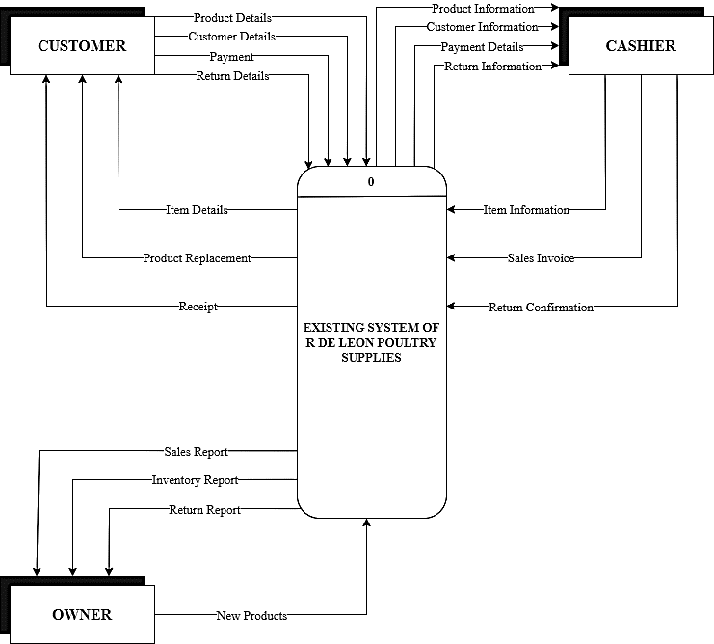

**Figure 2: Context Diagram of the Existing System**

Figure 2: shows the three entities involved: the customer, the cashier, and owner. The initial step in their traditional system involves the owner placing an order with the supplier, providing the order information, and making the payment. The supplier, in turn, arranges the ordered products and generates an invoice for delivery to the R De Leon Store. Once the owner receives all the items or products, they conduct an inventory check using a record book and produce an inventory report. The record book is manually updated to reflect the availability of the stocks.

After the inventory check, the customer can proceed with their transaction at the store. Initially, the customer may inquire about a product with the cashier, who then validates its availability in the record book. The cashier checks the list of available items and, upon successful validation, provides the customer with product details, including the price, quantity, and total cost. Subsequently, the customer can proceed with their transaction at the cashier's counter, handing over the payment. The cashier validates the payment and generates a receipt to be given to the customer.

If customers wish to return items purchased from the store, they are required to present the receipt received on the day of purchase to the cashier. The cashier then shares information about customers seeking returns with the store owner, along with the reasons for the return. In certain cases, the owner may permit returns or exchanges, even if more than a week or two has passed, with the maximum allowable period for returns being approximately three weeks. Customers with valid reasons for returning an item may receive a refund or exchange it for an item of the same purchase price.

In Addition, some of the orders and purchases are coming from Facebook platform. They message the owner and provide their order details. The owner will arrange the orders and then make a transaction from delivery partners like LBC or Lalamove. There is also a case in which the owner delivers the orders from their customers.

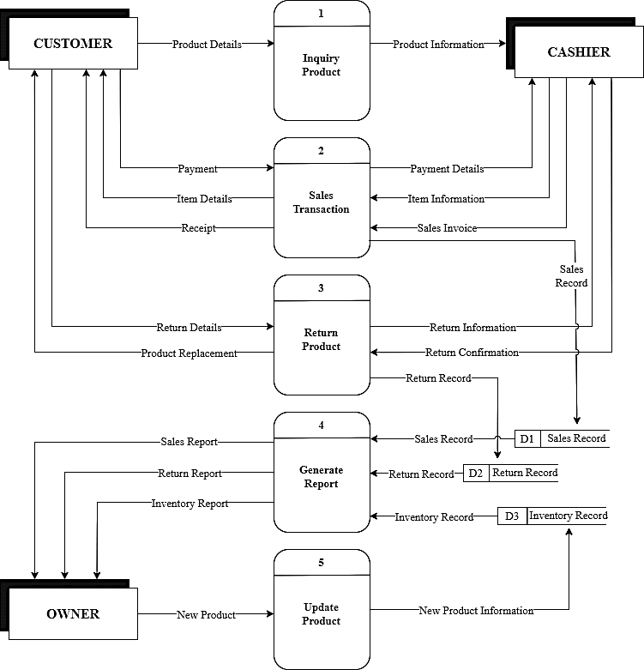

**Figure 3: Diagram 0 of the Existing System**

The customer will ask about a product from the cashier. The cashier checks the inventory record book and provides the customer with information about the product. The customer then provides their payment, and the cashier manually calculates the total amount to be paid. The cashier summarizes everything the customer ordered, creates a receipt, and gives it to the customer. The sales transaction is then manually recorded in the sales record, and the sales and inventory reports are given to the owner. When a customer wants to return a product, they will request a return from the cashier. The cashier will check the date of the product to see if it has been more than a week or two, with the longest allowable return period being about three weeks. The cashier will then check with the owner to determine if the customer's reason for returning the product is valid. When the supplier provides item supplies to the store, the items are recorded manually in the log invoices, and the owner is given a list of information about the items supplied by the supplier.

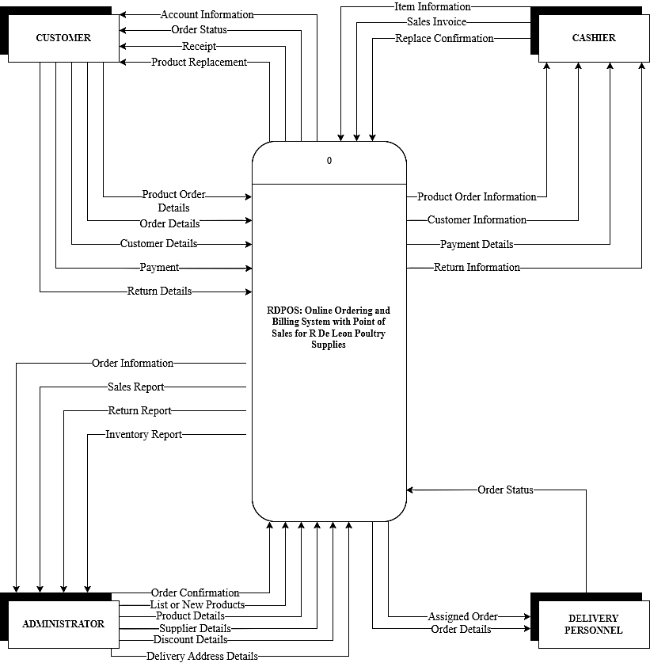

**Figure 4: Context Diagram of RDPOS**

Figure 4 shows the proposed diagram, which includes four entities: the administrator, cashier, customer, and delivery personnel. The administrator is responsible for managing the system, overseeing inventory processes, sales management, delivery order management, and report management. They can also add and customize product listings in the ordering and billing systems, as well as the point-of-sale system. Once product information is added or saved in the system, it can be displayed to customers on either the customer-facing side or the point-of-sale system.

If a customer wishes to purchase an item in-store, they can inquire about the product with the cashier. If they prefer to use the RDPOS online ordering system, they can view the product on the website and make inquiries immediately. Orders placed on the website are received by the administrator. The administrator can approve the order after confirming the customer's order list. The order is then forwarded to the delivery side for the delivery person to fulfill.

On the other hand, orders made in the point-of-sale system are received by the cashier. Once a product has been selected, the cashier and administrator can complete the transaction and provide the bill. Upon successful payment by the customer, a receipt is generated. If the payment transaction is successful, the order is received by the administrator, who then manages the order and customer details, assigning the delivery person to deliver the items to the customer.

After a successful delivery, the delivery person reports to the administrator with the delivery information. All transactions, sales reports, order reports, and stock updates are processed and managed by the administrator.

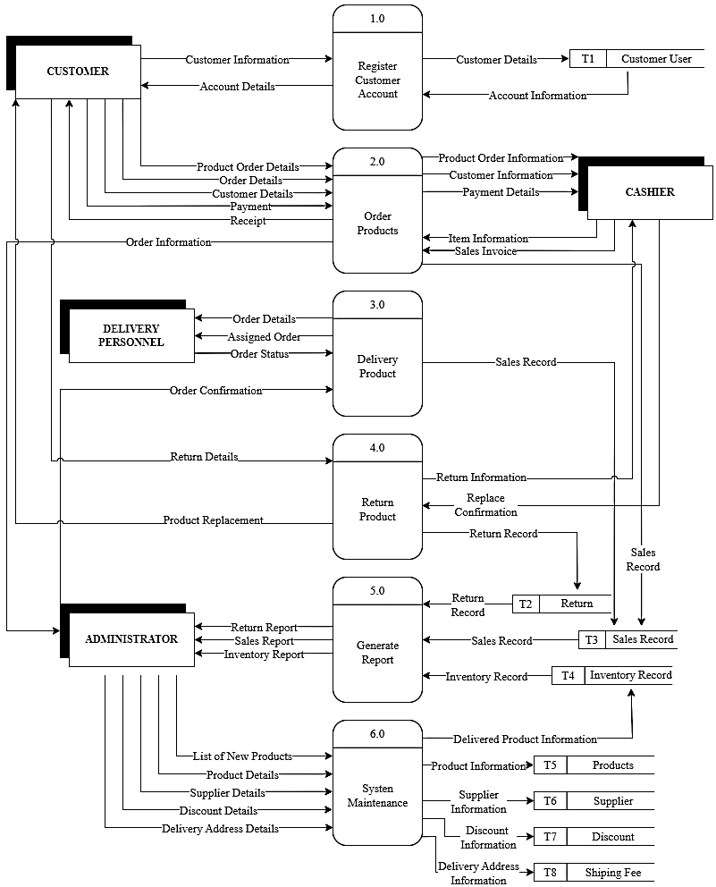

**Figure 5: Diagram 0 of RDPOS**

Figure 5 illustrates the RDPOS diagram, which involves the four entities: customer, cashier, delivery personnel, and administrator. The customer begins by accessing the website to browse and search for products. To engage with RDPOS, the customer must register an account and subsequently log in. Once logged in, they can add desired products to their cart. Upon satisfaction with the cart's contents, the customer is prompted to provide delivery information and complete the payment process, after which they can place an order. Upon receiving the delivery information, the delivery personnel is tasked with delivering all ordered products to the customer. Once the delivery is completed, the personnel update the system, indicating the delivery status and concluding the delivery process. In cases where customers make purchases in physical stores, they select and collect their chosen products before proceeding to the cashier. The cashier records the transaction through the POS system, informs the customer of the amount due, processes the payment, and returns any change along with a receipt. Additionally, both online and walk-in customers have the option to return a product. For in-store returns, customers must present the receipt, which the cashier validates by searching the POS system. If eligible for return, the cashier processes the return through the RDPOS system, allowing them to choose between replacement or refund.

*3.2.2 Use Case Diagram*

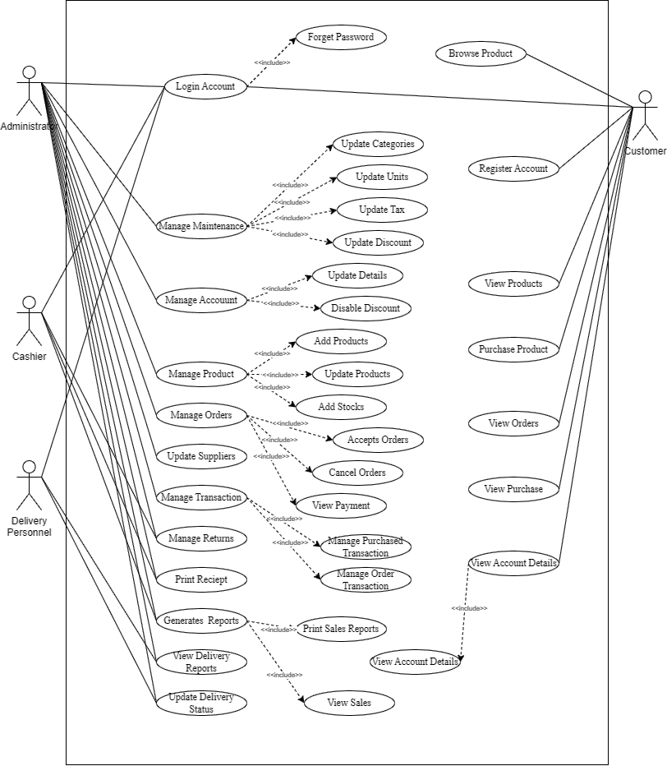The use case diagram depicts the events or actions occurring within the system or website. It illustrates the interactions among actors, the system, the website, and the mobile application.

**Figure 7: Use Case Diagram of RDPOS**

**1. Browse Products**

1.1 Introduction: This use case involves customers exploring the product catalog to discover and gather information about available products.

1.2 Actor:

(i) Customer

1.3 Pre-Condition: The customer must have an active internet connection and access to the website.

1.4 Post-Condition: The customer gains an overview of the products offered on the platform.

1.5 Basic Flow: The customer logs into their account, navigates to the "Browse Products" section and peruses the product listings.

(i) The system provides options for refining searches, such as filters and categories, enhancing the browsing experience.

1.6 Alternative Flow: None

1.7 Special Requirements: None

1.8 Use Case Relationship: None

**2. Login Account**

2.1 Introduction: This use case involves customers accessing their personalized accounts on the platform.

2.2 Actor:

(i) Customer

(ii) Administrator

(iii) Cashier

(iv) Delivery Personnel

(v) Supplier

2.3 Pre-Condition: The actors must have an account on the system.

2.4 Post-Condition: Upon successful login, the actors gain access to their respective account-specific features and information.

2.5 Basic Flow: The actors enter valid login credentials, and the system authenticates the users, granting access to their account.

(i) In the case of incorrect credentials, the system prompts the actors to re-enter the information.

2.6 Alternative Flow: None

2.7 Special Requirements: None

2.8 Use Case Relationship: None

**3. Register Account**

3.1 Introduction: This use case involves new customers creating accounts to access the platform's features.

3.2 Actor:

(i) Customer

3.3 Pre-Condition: The customer must have a valid email address and be willing to provide the required registration information.

3.4 Post-Condition: After successful registration, the customer receives a confirmation and gains access to the platform.

3.5 Basic Flow: The customer provides the necessary registration details, including email, username, and password. The system validates the information and creates a new account.

(i) If the provided email is already registered, the system prompts the customer to choose a different email.

3.6 Alternative Flow: None

3.7 Special Requirements: None

3.8 Use Case Relationship: None

**4. View Products**

4.1 Introduction: This use case involves customers accessing detailed information about specific products available on the platform.

4.2 Actor:

(i) Customer

4.3 Pre-Condition: The customer must be logged into their account.

4.4 Post-Condition: The customer gains insights into the features, pricing, and availability of the selected product.

4.5 Basic Flow: The customer navigates to the "View Products" section, selects a specific item, and reviews detailed information.

(i) The system may display related products or recommendations based on the customer's viewing history, enhancing the buying experience.

4.6 Alternative Flow: None

4.7 Special Requirements: None

4.8 Use Case Relationship: None

**5. Purchase Product**

5.1 Introduction: This use case involves customers selecting and purchasing a product after viewing detailed information.

5.2 Actor:

(i) Customer

5.3 Pre-Condition: The customer must be logged into their account and have successfully viewed product details.

5.4 Post-Condition: The customer completes a purchase, and the selected product is added to their order history.

5.5 Basic Flow: After viewing product details, the customer clicks on the "Purchase" option, selects payment and shipping details, and confirms the order.

(i) The system processes the payment, updates the inventory, and generates an order confirmation for the customer.

5.6 Alternative Flow: If the payment fails, the system notifies the customer and provides alternative payment options.

5.7 Special Requirements: None

5.8 Use Case Relationship: A successful product purchase is a continuation of the customer's product exploration and enhances the overall shopping experience.

**6. View Orders**

6.1 Introduction: This use case involves customers accessing and reviewing their order history.

6.2 Actor:

(i) Customer

6.3 Pre-Condition: The customer must be logged into their account.

6.4 Post-Condition: The customer gains insights into past and current orders, facilitating order tracking and management.

6.5 Basic Flow: The customer navigates to the "View Orders" section, where they can see a list of their past and current orders.

(i) The system provides order details such as order status, tracking information, and the option to view individual order details.

6.6 Alternative Flow: None

6.7 Special Requirements: None

6.8 Use Case Relationship: Accessing and reviewing orders allows the customer to stay informed about their purchase history and track the status of current orders.

**7. View Purchased**

7.1 Introduction: This use case involves customers reviewing detailed information about previously purchased products.

7.2 Actor:

(i) Customer

7.3 Pre-Condition: The customer must be logged into their account and have completed at least one purchase.

7.4 Post-Condition: The customer gains access to detailed information about their purchased products.

7.5 Basic Flow: The customer navigates to the "View Purchased" section, where they can see a list of products they have previously purchased.

(i) The system provides information such as order date, product details, and the option to view individual product details.

7.6 Alternative Flow: None

7.7 Special Requirements: None

7.8 Use Case Relationship: Viewing purchased products allows the customer to recall past purchases and access relevant information about those items.

**8. View Account Details**

8.1 Introduction: This use case involves customers accessing and managing their account information.

8.2 Actor:

(i) Customer

8.3 Pre-Condition: The customer must be logged into their account.

8.4 Post-Condition: The customer can review and update their account details, ensuring accurate and current information.

8.5 Basic Flow: The customer navigates to the "View Account Details" section, where they can see and modify personal information, passwords, and other account details.

(i) The system provides options for updating and securing account information.

8.6 Alternative Flow: None

8.7 Special Requirements: None

8.8 Use Case Relationship: Accessing and managing account details empowers the customer to maintain accurate and secure information on the platform.

**9. Manage Maintenance**

9.1 Introduction: This use case involves the Administrator overseeing and managing maintenance activities to ensure a smooth customer experience.

9.2 Actor:

(i) Administrator

9.3 Pre-Condition: The Administrator must have administrative privileges and be logged into the system.

9.4 Post-Condition: Maintenance tasks are successfully managed, contributing to the overall functionality and reliability of the platform for customers.

9.5 Basic Flow: The Administrator logs into the system, navigates to the "Manage Maintenance" section and addresses any ongoing or scheduled maintenance tasks.

(i) The system provides tools for tracking and updating maintenance progress, ensuring minimal disruption to customer interactions.

9.6 Alternative Flow: None

9.7 Special Requirements: None

9.8 Use Case Relationship: The effective management of maintenance contributes to a positive customer experience by minimizing downtimes and disruptions.

**10. Manage Accounts**

10.1 Introduction: This use case involves the Administrator overseeing customer accounts to ensure security, privacy, and efficient user management.

10.2 Actor:

(i) Administrator

10.3 Pre-Condition: The Administrator must have administrative privileges and be logged into the system.

10.4 Post-Condition: Customer accounts are effectively managed, promoting a secure and personalized experience for users.

10.5 Basic Flow: The Administrator navigates to the "Manage Accounts" section, where they can add, modify, or deactivate customer accounts as needed.

(i) The system provides tools for account verification, password management, and other account-related functions.

10.6 Alternative Flow: None

10.7 Special Requirements: None

10.8 Use Case Relationship: Efficient account management enhances customer security and ensures accurate access control.

**11. Manage Products**

11.1 Introduction: This use case involves the Administrator overseeing the product catalog to ensure accurate and up-to-date information for customers.

11.2 Actor:

(i) Administrator

11.3 Pre-Condition: The Administrator must have administrative privileges and be logged into the system.

11.4 Post-Condition: The product catalog is well-maintained, providing customers with accurate and relevant information.

11.5 Basic Flow: The Administrator navigates to the "Manage Products" section, where they can add, update, or remove products from the catalog.

(i) The system provides tools for managing product descriptions, images, and pricing information.

11.6 Alternative Flow: None

11.7 Special Requirements: None

11.8 Use Case Relationship: Effective product management ensures customers have access to the latest and most accurate product information.

**12. Manage Orders**

12.1 Introduction: This use case involves the Administrator overseeing and managing customer orders to ensure timely processing and delivery.

12.2 Actor:

(i) Administrator

12.3 Pre-Condition: The Administrator must have administrative privileges and be logged into the system.

12.4 Post-Condition: Customer orders are efficiently managed, leading to accurate processing and timely deliveries.

12.5 Basic Flow: The Administrator navigates to the "Manage Orders" section, where they can track and update order statuses.

(i) The system provides tools for resolving order-related issues, communicating with customers, and ensuring a smooth order fulfillment process.

12.6 Alternative Flow: None

12.7 Special Requirements: None

12.8 Use Case Relationship: Effective order management contributes to a positive customer experience by ensuring timely and accurate order processing.

**13. Update Suppliers**

13.1 Introduction: This use case involves the Administrator updating and managing information related to suppliers on the platform.

13.2 Actor:

(i) Administrator

(ii) Suppliers

13.3 Pre-Condition: The Administrator must have administrative privileges and be logged into the system. Suppliers must be registered on the platform.

13.4 Post-Condition: Supplier information is updated, ensuring accuracy and transparency in dealings between the platform and suppliers.

13.5 Basic Flow: The Administrator navigates to the "Update Suppliers" section, where they can modify supplier details, such as contact information, product offerings, and delivery terms.

(i) Suppliers may have access to a portal where they can submit updated information or respond to queries from the Administrator.

13.6 Alternative Flow: If there are discrepancies in the information provided by suppliers, the Administrator may contact the suppliers for clarification and updates.

13.7 Special Requirements: None

13.8 Use Case Relationship: Keeping supplier information up-to-date is crucial for maintaining effective communication and collaboration, ensuring a seamless supply chain for the platform.

**14. Manage Transactions**

14.1 Introduction: This use case involves the Administrator and Cashier collaborating to manage and oversee financial transactions on the platform.

14.2 Actor:

(i) Administrator

(ii) Cashier

14.3 Pre-Condition: The Administrator must have administrative privileges, and the Cashier must be logged into the system. A transaction must be initiated.

14.4 Post-Condition: Financial transactions are successfully managed and recorded, ensuring accuracy in financial records.

14.5 Basic Flow: The Cashier initiates a transaction, and the Administrator, with their administrative privileges, reviews and manages the transaction details, including verification, approval, and documentation.

14.6 Alternative Flow: If there are discrepancies or issues with a transaction, the Administrator collaborates with the Cashier to resolve them and ensure accurate financial records.

14.7 Special Requirements: None

14.8 Use Case Relationship: Effective collaboration between the Administrator and Cashier in managing transactions ensures financial accuracy and accountability on the platform.

**15. Manage Returns**

15.1 Introduction: This use case involves the Administrator and Cashier coordinating to manage product returns on the platform.

15.2 Actor:

(i) Administrator

(ii) Cashier

15.3 Pre-Condition: The Administrator must have administrative privileges, and the Cashier must be logged into the system. A return request must be initiated.

15.4 Post-Condition: Product returns are efficiently managed, ensuring customer satisfaction and accurate inventory records.

15.5 Basic Flow: The Cashier initiates a return request, and the Administrator reviews and manages the return process, including verification, approval, and updating inventory.

15.6 Alternative Flow: If there are issues with the return request or discrepancies in the returned product, the Administrator collaborates with the Cashier to address and resolve them.

15.7 Special Requirements: None

15.8 Use Case Relationship: Collaboration between the Administrator and Cashier in managing returns contributes to customer satisfaction and maintains accurate inventory levels.

**16. Print Receipt**

16.1 Introduction: This use case involves the Cashier generating and printing receipts for completed transactions.

16.2 Actor:

(i) Cashier

16.3 Pre-Condition: The Cashier must be logged into the system, and a completed transaction must exist.

16.4 Post-Condition: A receipt for the transaction is successfully generated and printed for the customer.

16.5 Basic Flow: The Cashier navigates to the "Print Receipt" section, selects the relevant completed transaction, and generates a receipt for the customer.

16.6 Alternative Flow: If there are issues with printing the receipt, the Cashier troubleshoots or seeks assistance from the Administrator.

16.7 Special Requirements: None

16.8 Use Case Relationship: Printing receipts is an essential part of the transaction process, providing customers with documentation of their purchases.

**17. Generate Reports**

17.1 Introduction: This use case involves the Administrator generating reports to analyze and track various aspects of the platform's performance.

17.2 Actor:

(i) Administrator

17.3 Pre-Condition: The Administrator must have administrative privileges.

17.4 Post-Condition: Comprehensive reports are generated, providing valuable insights into the platform's financial and operational performance.

17.5 Basic Flow: The Administrator navigates to the "Generate Reports" section, selects the type of report needed (e.g., sales, inventory), and specifies the desired parameters.

17.6 Alternative Flow: If there are issues with generating reports or if specific data is unavailable, the Administrator troubleshoots or seeks assistance.

17.7 Special Requirements: None

17.8 Use Case Relationship: Generating reports allows the Administrator to make informed decisions, identify trends, and optimize various aspects of the platform's operations.

**18. View Delivery Product**

18.1 Introduction: This use case involves the Administrator and the Delivery personnel collaboratively managing and tracking product deliveries on the platform.

18.2 Actor:

(i) Administrator

(ii) Delivery Personnel

18.3 Pre-Condition: The Administrator must have administrative privileges, and the Delivery Personnel must be logged into the system. A delivery must be initiated.

18.4 Post-Condition: The Administrator and Delivery Personnel gain visibility into the status and details of the product to be delivered.

18.5 Basic Flow: The Delivery Personnel updates the system with the product's status, including its current location and estimated time of arrival. The Administrator can view this information in real-time.

18.6 Alternative Flow: If there are issues with the delivery process or discrepancies in the delivery information, the Administrator collaborates with the Delivery Personnel to address and resolve them.

18.7 Special Requirements: None

18.8 Use Case Relationship: Collaborative tracking of deliveries between the Administrator and Delivery Personnel ensures transparency and efficiency in the delivery process.

**19. Update Delivery Status**

19.1 Introduction: This use case involves the Administrator and Delivery Personnel updating the status of product deliveries on the platform.

19.2 Actor:

(i) Administrator

(ii) Delivery Personnel

19.3 Pre-Condition: The Administrator must have administrative privileges, and the Delivery Personnel must be logged into the system. Delivery must be ongoing.

19.4 Post-Condition: The status of the product delivery is successfully updated, providing accurate and real-time information to customers and the Administrator.

19.5 Basic Flow: The Delivery Personnel updates the system with the current status of the delivery, such as "Out for Delivery" or "Delivered." The Administrator and customers can view this updated status.

19.6 Alternative Flow: If there are challenges in updating the delivery status or if additional information is required, the Administrator collaborates with the Delivery Personnel to resolve the issue.

19.7 Special Requirements: None

19.8 Use Case Relationship: Timely and accurate updates to the delivery status enhance customer satisfaction and provide the Administrator with real-time insights into the fulfillment process.

*3.2.3 Entity Relationship Diagram*

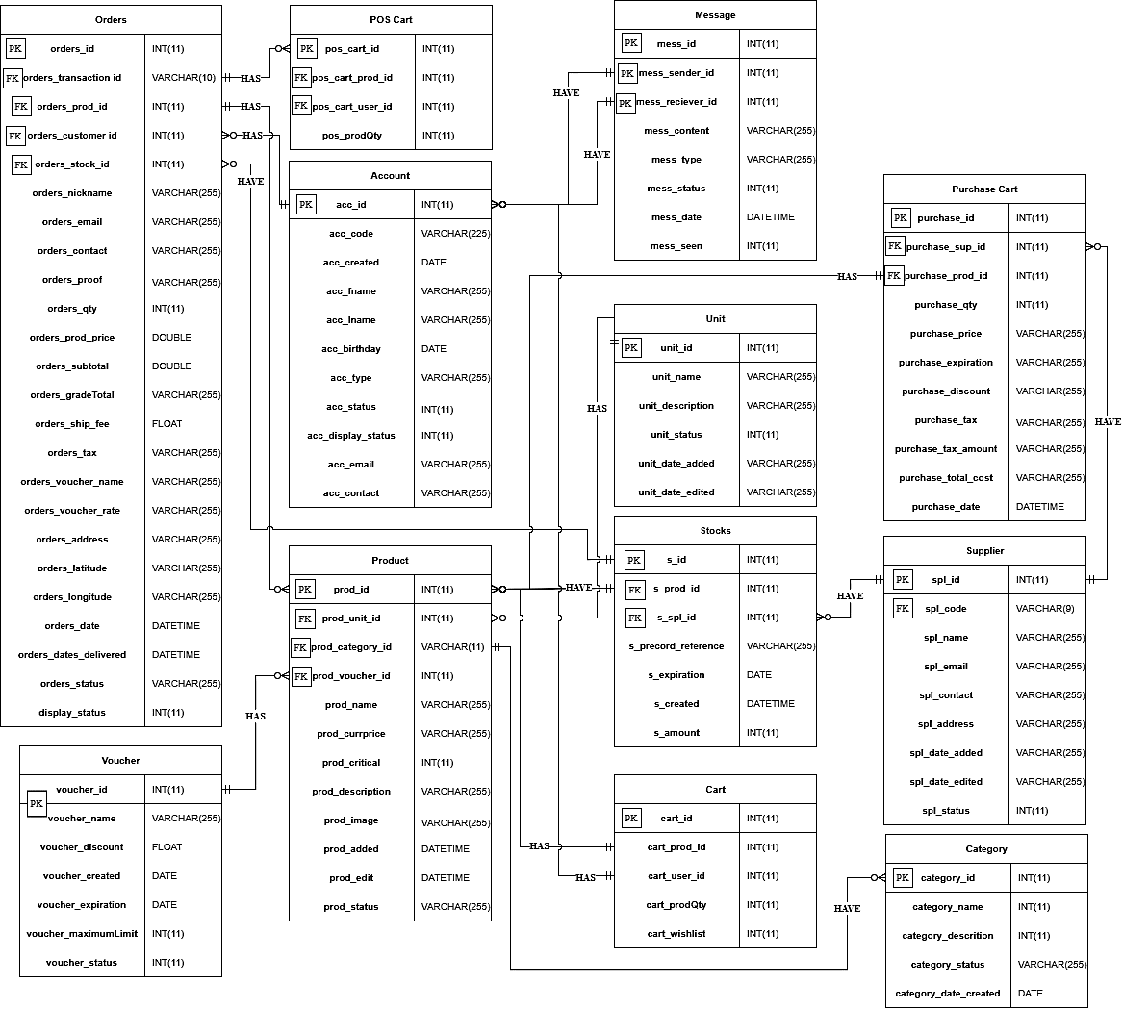

**Figure 8: Entity Relationship Diagram**

*3.2.4 Data Dictionary*

The data dictionary shows all the tables in the database of the system Online Ordering and Billing System with Point of Sales for R De Leon Poultry Supplies

**Table 1: Account**

|  |  |  |  |  |
| --- | --- | --- | --- | --- |
| **Field Name** | **Field Type/Length** | **Required** | **Key** | **Domain** |
| acc_id | INT (7) | YES | PK | Contains account Id. |
| acc_code | VARCHAR (7) | YES |  | Contains account code. |
| acc_created | DATE | YES |  | Contains account created. |
| acc_fname | VARCHAR(20) | YES |  | Contains the account's first name. |
| acc_lname | VARCHAR(20) | YES |  | Contains the account's last name. |
| acc_birthday | DATE | YES |  | Contains the account’s birthday. |
| acc_type | VARCHAR(10) | YES |  | Contains the account’s type. |
| acc_status | INT(1) | YES |  | Contains the account’s status. |
| acc_display status | INT (1) | YES |  | Contains the account ‘s display status. |
| acc_email | VARCHAR(25) | YES |  | Contains account email. |
| acc_contact | VARCHAR(11) | YES |  | Contains account contact. |
| acc_image | VARCHAR(255) | YES |  | Contains account image. |
| acc_cover_img | VARCHAR(255) | YES |  | Contains an account cover image. |
| acc_added | DATETIME | YES |  | Contains account added. |
| acc_lastEdit | DATETIME | YES |  | Contains account's last Edit. |

**Table 2: Address**

|  |  |  |  |  |
| --- | --- | --- | --- | --- |
| **Field Name** | **Field Type/Length** | **Required** | **Key** | **Domain** |
| address_region_id | INT(17) | YES | PK | Contains address id |
| address_psgc_code | VARCHAR(20) | YES |  | Contains the address page code. |
| address_region_name | VARCHAR(10) | YES |  | Contains the address region name. |
| address_region_code | VARCHAR(10) | YES |  | Contains the address region code. |
| address_rate | DOUBLE | YES |  | Contains the address rate. |
| address_status | INT(1) | YES |  | Contains the address status. |
| address_date_edited | DATETIME | YES |  | Contains the address date edited. |

**Table 3: Cart**

|  |  |  |  |  |
| --- | --- | --- | --- | --- |
| **Field Name** | **Field Type/Length** | **Required** | **Key** | **Domain** |
| cart_id | INT (3) | YES | PK | It contains the cart ID. |
| cart_prod_id | INT(7) | YES | FK | It contains the cart product ID. |
| cart_user_id | INT(7) | YES | FK | Contains the cart user ID. |
| cart_prodQty | INT(7) | YES |  | Contains the cart product quantity. |

**Table 4: Category**

|  |  |  |  |  |
| --- | --- | --- | --- | --- |
| **Field Name** | **Field Type/Length** | **Required** | **Key** | **Domain** |
| category_id | INT (3) | YES | PK | Contains the category id. |
| category_name | VARCHAR (20) | YES |  | Contains the category name. |
| category_descrition | VARCHAR(255) | YES |  | Contains the category description. |
| category_status | INT (1) | YES |  | Contains the category status. |
| category_date_created | DATE TIME | YES |  | Contains the category date created. |
| category_date_edited | DATE TIME | YES |  | Contains the category date edited. |

**Table 5: Discount**

|  |  |  |  |  |
| --- | --- | --- | --- | --- |
| **Field Name** | **Field Type/Length** | **Required** | **Key** | **Domain** |
| discount_id | INT (3) | YES | PK | Contains the discount ID. |
| discount_name | VARCHAR (20) | YES |  | Contains the discount name. |
| discount_rate | DOUBLE | YES |  | Contains the discount rate. |
| discount_status | INT (1) | YES |  | Contains the discount status. |

**Table 6: Maintenance**

|  |  |  |  |  |
| --- | --- | --- | --- | --- |
| **Field Name** | **Field Type/Length** | **Required** | **Key** | **Domain** |
| system_id | INT (1) | YES | PK | Contains the system ID. |
| system_name | VARCHAR (20) | YES |  | Contains the system name. |
| system_banner | VARCHAR (225) | YES |  | Contains the system banner. |
| system_logo | VARCHAR (225) | YES |  | Contains the system logo. |
| system_content | TEXT | YES |  | Contains the system content. |
| system_address | VARCHAR (225) | YES |  | Contains the system address. |
| system_contact | VARCHAR (11) | YES |  | Contains the system contact number. |
| system_tax | DOUBLE | YES |  | Contains the system tax. |
| system_last_update | DATETIME | YES |  | Contains the system last update. |

**Table 7: Messages**

|  |  |  |  |  |
| --- | --- | --- | --- | --- |
| **Field Name** | **Field Type/Length** | **Required** | **Key** | **Domain** |
| mess_id | INT(7) | YES | PK | Contains the messages ID. |
| mess_sender_id | INT(7) | YES | FK | Contains the messages sender ID. |
| mess_content | TEXT | YES |  | Contains the message content. |
| mess_type | INT(1) | YES |  | Contains the message type. |
| mess_status | INT(1) | YES |  | Contains the message's status. |
| mess_reciever_id | INT(7) | YES | FK | Contains the messages receiver ID. |
| mess_date | DATETIME | YES |  | Contains the messages date. |

**Table 8: Mode of payment**

|  |  |  |  |  |
| --- | --- | --- | --- | --- |
| **Field Name** | **Field Type/Length** | **Required** | **Key** | **Domain** |
| payment_id | INT (7) | YES | PK | Contains the payment ID. |
| payment_code | VARCHAR(9) | YES |  | Contains the payment code. |
| payment_name | VARCHAR(20) | YES |  | Contains the payment name. |
| payment_number | VARCHAR(11) | YES |  | Contains the payment number. |
| payment_image | VARCHAR(255) | YES |  | Contains the payment image. |
| payment_status | INT(1) | YES |  | Contains the payment status. |
| payment_type | VARCHAR(20) | YES |  | Contains the payment type. |
| payment_date | DATETIME | YES |  | Contains the payment date. |
| payment_date_added | DATETIME | YES |  | Contains the payment date added. |
| payment_date_edited | DATETIME | YES |  | Contains the payment date edited. |

**Table 9: Orders**

|  |  |  |  |  |
| --- | --- | --- | --- | --- |
| **Field Name** | **Field Type/Length** | **Required** | **Key** | **Domain** |
| orders_id | INT(7) | YES | PK | Contains the orders ID. |
| orders_transaction id | VARCHAR(7) | YES | FK | Contains the orders transactionID. |
| orders_prod_id | INT(7) | YES | FK | Contains the product ID. |
| orders_customer id | INT(7) | YES | FK | Contains the customer ID. |
| orders_payment_id | INT (7) | YES |  | Contains the payment method. |
| orders_proof | VARCHAR(255) | YES |  | Contains the proof. |
| orders_qty | INT(7) | YES |  | Contains the quantity. |
| orders_stock_id | INT(7) | YES | FK | Contains the stock ID. |
| orders_prod_price | DOUBLE | YES |  | Contains the product ID. |
| orders_subtotal | DOUBLE | YES |  | Contains the product price. |
| orders_grandTotal | DOUBLE | YES |  | Contains the subtotal. |
| orders_ship_fee | DOUBLE | YES |  | Contains the grade total. |
| orders_tax | DOUBLE | YES |  | Contains the ship fee. |
| orders_discount__id | VARCHAR(7) | YES |  | Contains the tax. |
| orders_address | VARCHAR(255) | YES |  | Contains the address. |
| orders_date | DATETIME | YES |  | Contains the order date. |
| orders_dates_delivered | DATETIME | YES |  | Contains the dates delivered. |
| orders_status | INT(1) | YES |  | Contains the order status. |
| display_status | INT(1) | YES |  | Contains the display status. |

**Table 10: POS Cart**

|  |  |  |  |  |
| --- | --- | --- | --- | --- |
| **Field Name** | **Field Type/Length** | **Required** | **Key** | **Domain** |
| pos_cart_id | INT(3) | YES | PK | Contains the POS cart ID. |
| pos_cart_prod_id | INT(7) | YES | FK | Contains the POS cart Product ID. |
| pos_cart_user_id | INT(7) | YES | FK | Contains the pos cart user ID. |
| pos_prodQty | INT(7) | YES |  | Contains the pos products quantity. |

**Table 11: POS Orders**

|  |  |  |  |  |
| --- | --- | --- | --- | --- |
| **Field Name** | **Field Type/Length** | **Required** | **Key** | **Domain** |
| orders_order_id | INT(7) | YES | PK | Contains the order ID. |
| orders_tcode | VARCHAR(10) | YES |  | Contains the table code. |
| orders_prod_id | INT(7) | YES | FK | Contains the product ID. |
| orders_cart_id | INT(3) | YES | FK | Contains the cart ID. |
| orders_prodQty | INT(7) | YES |  | Contains the product quantity. |
| orders_discount_id | INT(1) | YES |  | Contains a discount. |
| orders_tax_id | INT(1) | YES |  | Contains the order tax |
| orders_date | DATETIME | YES |  | Contains order date. |
| orders_final | DOUBLE | YES |  | Contains the final order. |
| orders_payment | DOUBLE | YES |  | Contains the order payment. |
| orders_change | DOUBLE | YES |  | Contains the order change. |
| orders_user_id | INT(7) | YES | FK | Contains the order user-ID. |
| orders_status | INT(1) | YES |  | Contains the order status. |

**Table 12: Product**

|  |  |  |  |  |
| --- | --- | --- | --- | --- |
| **Field Name** | **Field Type/Length** | **Required** | **Key** | **Domain** |
| prod_id | INT(7) | YES | PK | Contains the product ID. |
| prod_code | VARCHAR(10) | YES |  | Contains the product code. |
| prod_name | VARCHAR(255) | YES |  | Contains the product name. |
| prod_currprice | DOUBLE | YES |  | Contains the product's current price. |
| prod_unit_id | INT(1) | YES | FK | Contains the product ID. |
| prod_category_id | VARCHAR(1) | YES | FK | Contains the product category ID. |
| prod_critical | INT(11) | YES |  | Contains the product critical. |
| prod_description | TEXT | YES |  | Contains the product description. |
| prod_order_discount__id | INT(1) | YES | FK | Contains the product order_discount_ ID. |
| prod_image | VARCHAR(255) | YES |  | Contains the product image. |
| prod_added | DATETIME | YES |  | Contains the product added. |
| prod_edit | DATETIME | YES |  | Contains the product edit. |
| prod_status | INT(1) | YES |  | Contains the product status. |

**Table 13: Purchase Cart**

|  |  |  |  |  |
| --- | --- | --- | --- | --- |
| **Field Name** | **Field Type/Length** | **Required** | **Key** | **Domain** |
| purchase_id | INT(7) | YES | PK | Contains the purchase ID. |
| purchase_sup_id | INT(7) | YES | FK | Contains the purchase supplier ID. |
| purchase_prod_id | INT(7) | YES | FK | Contains the purchase product ID. |
| purchase_qty | INT(7) | YES |  | Contains the purchase quantity. |
| purchase_price | DOUBLE | YES |  | Contains the purchase price. |
| purchase_expiration | DATETIME | YES |  | Contains the purchase expiration. |
| purchase_discount_id | INT(1) | YES |  | Contains the purchase discount. |
| purchase_tax | DOUBLE | YES |  | Contains the purchase tax. |
| purchase_tax_amount | DOUBLE | YES |  | Contains the purchase tax amount. |
| purchase_total_cost | DOUBLE | YES |  | Contains the purchase total cost. |
| purchase_date | DATETIME |  |  | Contains the purchase date. |

**Table 14: Purchased Record**

|  |  |  |  |  |
| --- | --- | --- | --- | --- |
| **Field Name** | **Field Type/Length** | **Required** | **Key** | **Domain** |
| precord_id | INT(7) | YES | PK | Contains the purchased record ID. |
| precord_sup_id | INT(7) | YES | FK | Contains the supplier ID. |
| precord_prod_id | INT(7) | YES | FK | Contains the product ID. |
| precord_qty | INT(7) | YES |  | Contains the purchased record quantity. |
| precord_reference | VARCHAR(255) | YES |  | Contains the purchased record reference. |
| precord_price | DOUBLE | YES |  | Contains the purchased record price. |
| precord_expiration | DATE | YES |  | Contains the expiration. |
| precord_discount | DOUBLE | YES |  | Contains the purchased record discount. |
| precord_tax | DOUBLE | YES |  | Contains the purchased record tax. |
| precord_tax_amount | DOUBLE | YES |  | Contains the tax amount. |
| precord_total_cost | DOUBLE | YES |  | Contains the total cost. |
| precord_date | DATETIME | YES |  | Contains the purchased record date. |
| precord_status | INT(1) | YES |  | Contains the purchased record status. |

**Table 15: Return POS**

|  |  |  |  |  |
| --- | --- | --- | --- | --- |
| **Field Name** | **Field Type/Length** | **Required** | **Key** | **Domain** |
| ret_id | INT(7) | YES | PK | Contains the Return POS ID. |
| ret_date | TIMESTAMP | YES |  | Contains the date. |
| ret_datepurchase | DATETIME | YES |  | Contains the date of purchase. |
| ret_transaction_code | VARCHAR(8) | YES |  | Contains the transaction code. |
| ret_product_code | VARCHAR(11) | YES |  | Contains the product code. |
| ret_qty | INT(11) | YES |  | Contains the Return POS quantity. |
| ret_request | VARCHAR(255) | YES |  | Contains the Return POS request. |
| ret_reason | VARCHAR(255) | YES |  | Contains the Return POS reason. |
| ret_customer_name | VARCHAR(255) | YES |  | Contains the customer’s name. |
| ret_number | VARCHAR(255) | YES |  | Contains the Return POS number |
| ret_address | VARCHAR(255) | YES |  | Contains the Return POS address. |
| ret_status | INT(11) | YES |  | Contains the Return POS status. |

**Table 16: Return Ordering**

|  |  |  |  |  |
| --- | --- | --- | --- | --- |
| Field Name | Field Type/Length | Required | Key | Domain |
| ret_ol_id | INT(7) | YES | PK | Contains the return ordering ID. |
| ret_ol_date | DATETIME | YES |  | Contains the return ordering date. |
| ret_ol_datepurchase | DATETIME | YES |  | Contains the date purchase. |
| ret_ol_transaction_code | VARCHAR(8) | YES |  | Contains the transaction code. |
| ret_ol_product_code | VARCHAR(11) | YES |  | Contains the product code. |
| ret_ol_qty | INT(7) | YES |  | Contains the return ordering quantity. |
| ret_ol_request | VARCHAR(255) | YES |  | Contains the return ordering request. |
| ret_ol_paymethod | VARCHAR(20) | YES |  | Contains the return ordering payment. |
| ret_ol_reason` | TEXT | YES |  | Contains the return ordering reason. |
| ret_ol_customer_name | VARCHAR(20) | YES |  | Contains the customer’s name. |
| ret_ol_contact_number | INT(11) | YES |  | Contains the contact number. |
| ret_ol_address | VARCHAR(255) | YES |  | Contains the return ordering address. |
| ret_ol_status | INT(1) | YES |  | Contains the return ordering status. |

**Table 17: Stocks**

|  |  |  |  |  |
| --- | --- | --- | --- | --- |
| Field Name | Field Type/Length | Required | Key | Domain |
| s_id | INT(7) | YES | PK | Contains the stocks ID. |
| s_created | DATETIME | YES |  | Contains the stocks created. |
| s_precord_reference | VARCHAR(10) | YES |  | Contains the stocks record reference. |
| s_expiration | DATETIME | YES |  | Contains the stock's expiration. |
| s_prod_id | INT(11) | YES | FK | Contains the stocks product ID. |
| s_amount | INT(11) | YES |  | Contains the stocks amount. |
| s_spl_id | INT(11) | YES | FK | Contains stocks supplier ID. |

**Table 18: Supplier**

|  |  |  |  |  |
| --- | --- | --- | --- | --- |
| **Field Name** | **Field Type/Length** | **Required** | **Key** | **Domain** |
| spl id | INT(11) | YES | PK | Contains the Supplier ID. |
| spl_code | VARCHAR(9) | YES |  | Contains the Supplier code. |
| spl_name | VARCHAR(20) | YES |  | Contains the Supplier name. |
| spl_email | VARCHAR(20) | YES |  | Contains the Supplier's email. |
| spl_contact | INT(11) | YES |  | Contains the Supplier contact. |
| spl_address | VARCHAR(255) | YES |  | Contains the Supplier's address. |
| spl_date_added | DATETIME | YES |  | Contains the Suppliers’ date added. |
| spl_date_edited | DATETIME | YES |  | Contains the Supplier’s date edited. |
| spl_status | INT(1) | YES |  | Contains the Supplier’s status. |

**Table 19: Unit**

|  |  |  |  |  |
| --- | --- | --- | --- | --- |
| **Field Name** | **Field Type/Length** | **Required** | **Key** | **Domain** |
| unit_id | INT(7) | YES | PK | Contains the unit ID. |
| unit_name | VARCHAR(20) | YES |  | Contains the unit’s name. |
| unit_description | TEXT | YES |  | Contains the unit description. |
| unit_status | INT(1) | YES |  | Contains the unit status. |
| unit_date_added | DATETIME | YES |  | Contains the unit date added. |
| unit_date_edited | DATETIME | YES |  | Contains the unit date edited. |

**Table 20: User Log**

|  |  |  |  |  |
| --- | --- | --- | --- | --- |
| **Field Name** | **Field Type/Length** | **Required** | **Key** | **Domain** |
| act_id | INT(7) | YES | PK | Contains the User Log ID. |
| act_account_ | INT(7) | YES |  | Contains the User Log account. |
| act_activity | TEXT | YES |  | Contains the User Log activity. |
| act_date | DATETIME | YES |  | Contains the User Log date. |
| act_table | VARCHAR(20) | YES |  | Contains the User Log table. |
| ct_collumn_id | VARCHAR(20) | YES | FK | Contains User Log column ID. |
| act_seen | INT(1) | YES |  | Contains the User Log seen. |

**Table 21: User Address**

|  |  |  |  |  |
| --- | --- | --- | --- | --- |
| **Field Name** | **Field Type/Length** | **Required** | **Key** | **Domain** |
| id | INT(7) | YES | PK | Contains the ID. |
| user_acc_code | VARCHAR(10) | YES |  | Contains the user account code. |
| user_address_fullname | VARCHAR(20) | YES |  | Contains the user address full name. |
| user_address_phone | INT(11) | YES |  | Contains the user address phone. |
| user_address_email | VARCHAR(20) | YES |  | Contains the user’s address email. |
| user_region_code | VARCHAR(255) | YES |  | Contains the user’s region code. |
| user_region_name | VARCHAR(255) | YES |  | Contains the user’s region name. |
| user_complete_address | VARCHAR(255) | YES |  | Contains the user's complete address. |
| user_active_status | INT(11) | YES |  | Contains the user’s active status. |
| user_add_display_status | INT(11) | YES |  | Contains the user’s add display status. |
| user_add_Default_status | INT(11) | YES |  | Contains the user’s add default status. |

**Table 22: Order_Discount**

|  |  |  |  |  |
| --- | --- | --- | --- | --- |
| **Field Name** | **Field Type/Length** | **Required** | **Key** | **Domain** |
| order_discount_id | INT(11) | YES | PK | Contains the order_discount_ ID. |
| order_discount__name | VARCHAR(255) | YES |  | Contains the order_discount_ name. |
| order_discount__discount | FLOAT | YES |  | Contains the order_discount_ discount. |
| order_discount__created | DATE | YES |  | Contains the order_discount_ created. |
| order_discount__expiration | DATE | YES |  | Contains the order_discount_ expiration. |
| order_discount__maximumLimit | INT(11) | YES |  | Contains the order_discount_ maximum limit. |
| order_discount__status | INT(11) | YES |  | Contains the order_discount_ status. |

**3.3. Project Design**

*3.3.1 Screen Layouts­­­­­­­­­­*

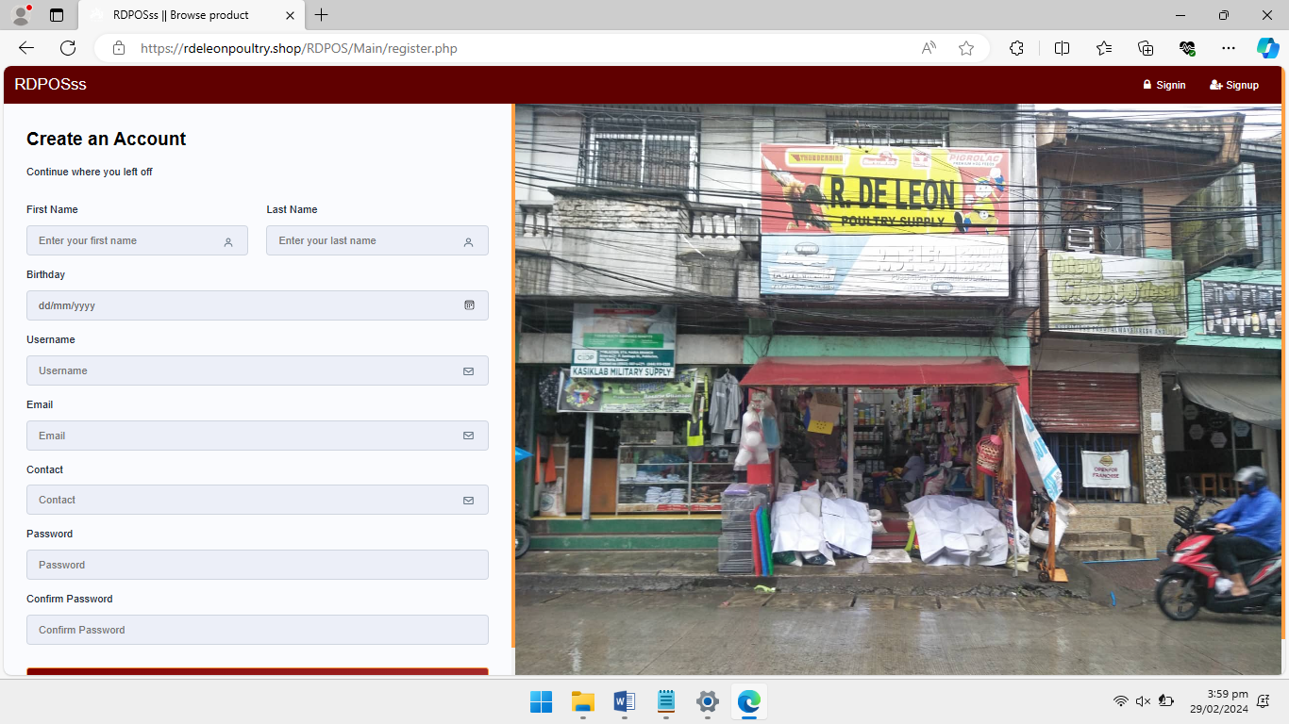

**Figure 9: Registration Personal Information**

The screenshot shows capture personal information during registration.

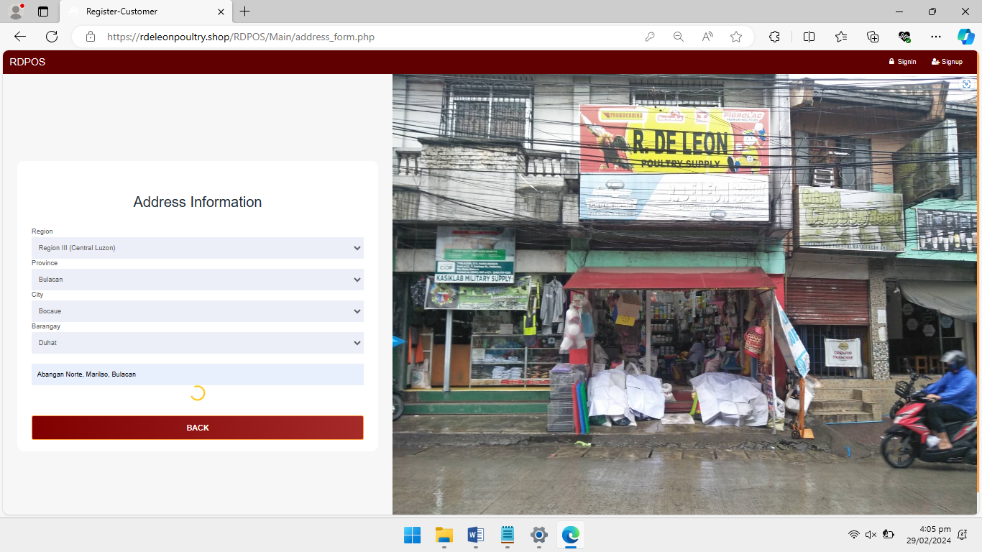

**Figure 10: Registration Address**

*Record user address details during registration.*

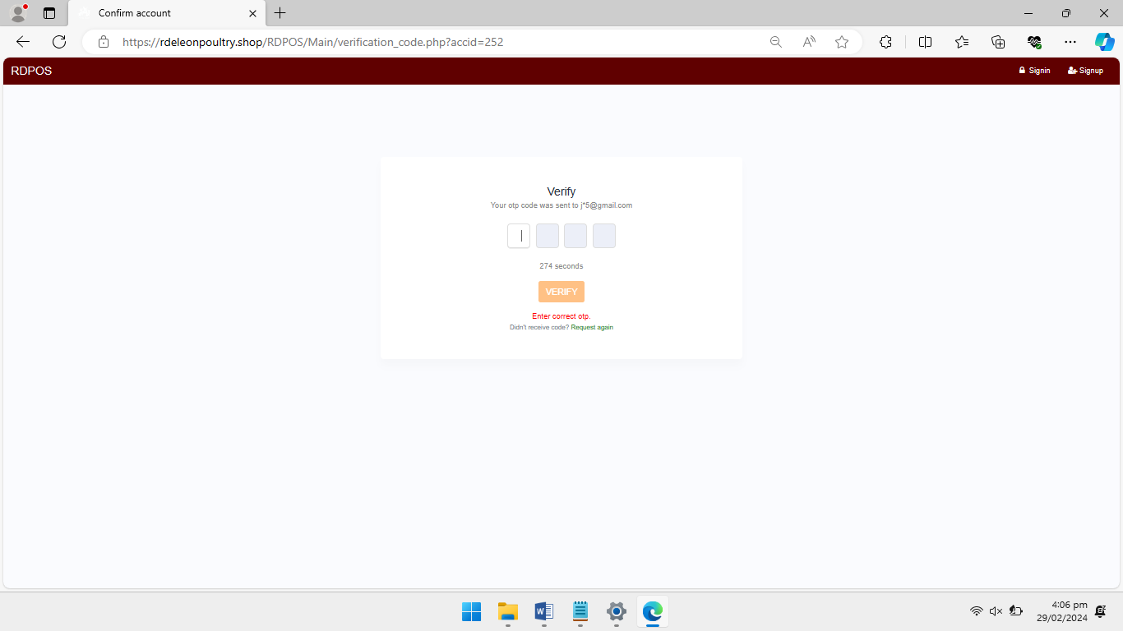

**Figure 11: OTP Section**

Display section for entering OTP (One-Time Password).

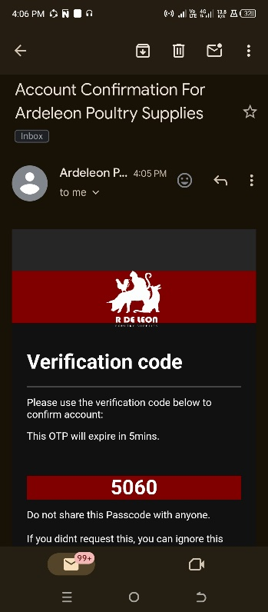

**Figure 12: OTP Code**

Input field for entering OTP code.

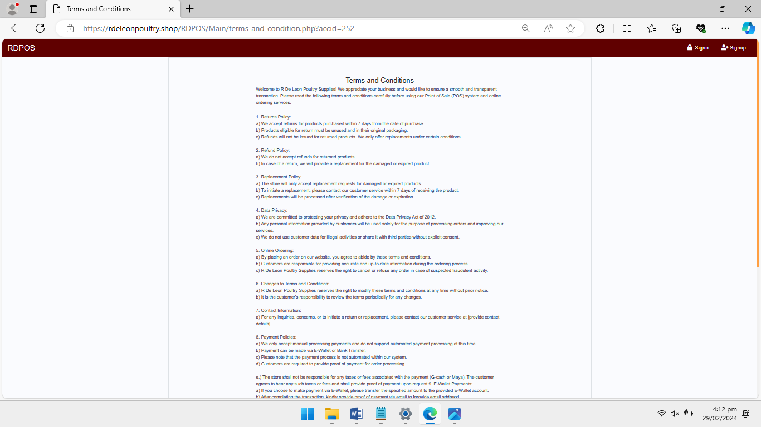

**Figure 13: Terms and Condition**

Present terms and conditions for user agreement.

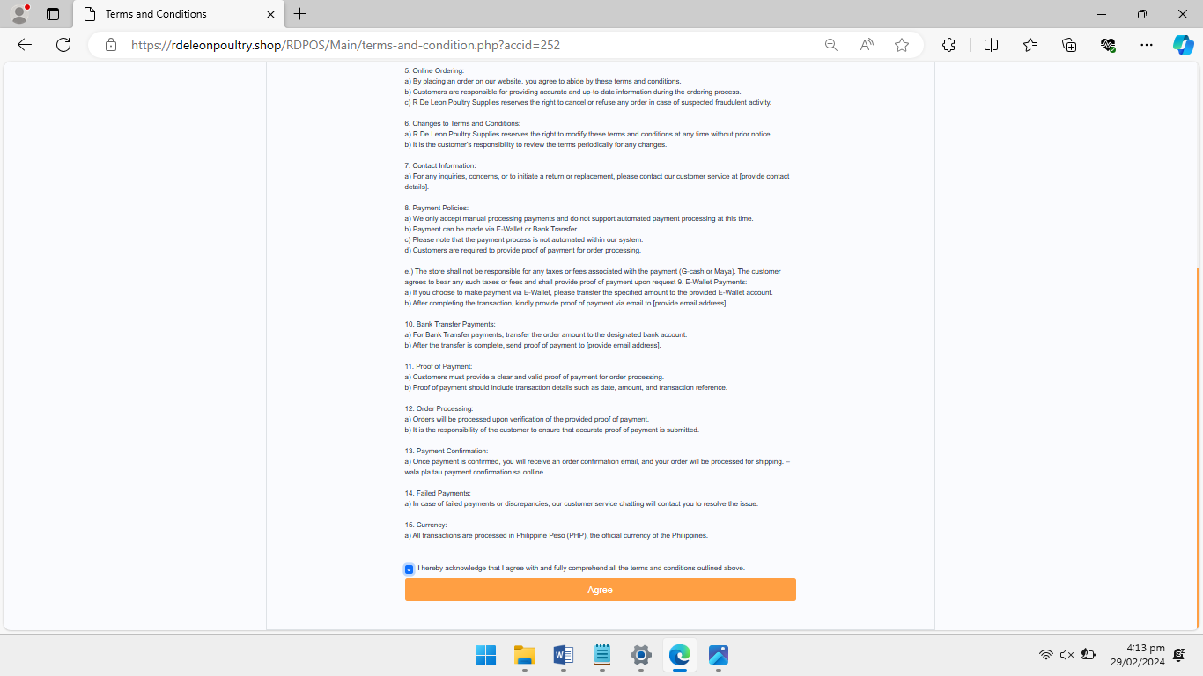

**Figure 14: Terms and Condition I Agreement Checkbox**

Checkbox to indicate agreement with terms.

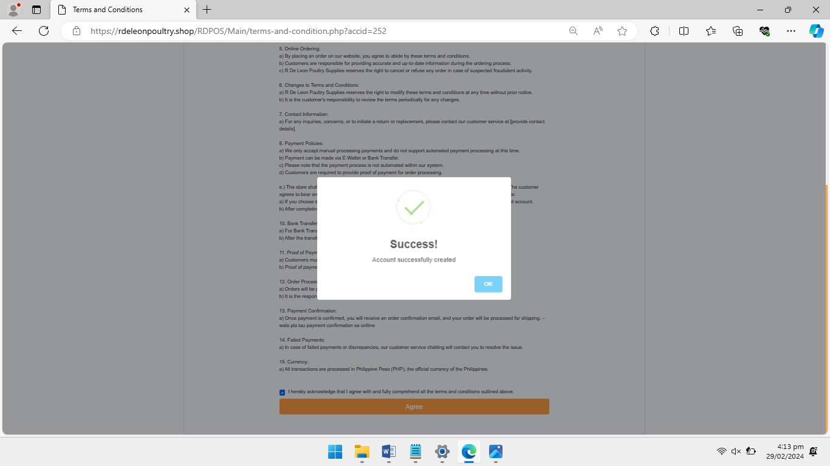

**Figure 15: Agreement Success Modal**

Page for users to navigate their account post-registration

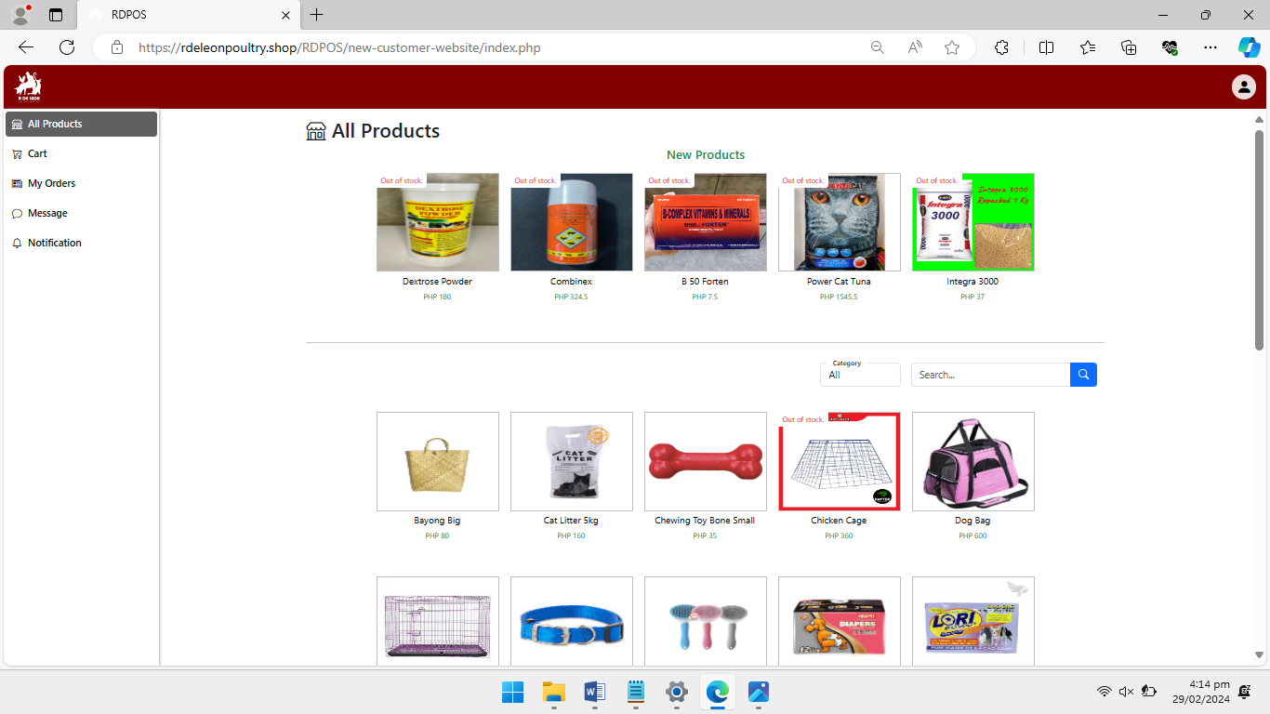

**Figure 16: Customer Landing Page**

Display the cart contents for user review.

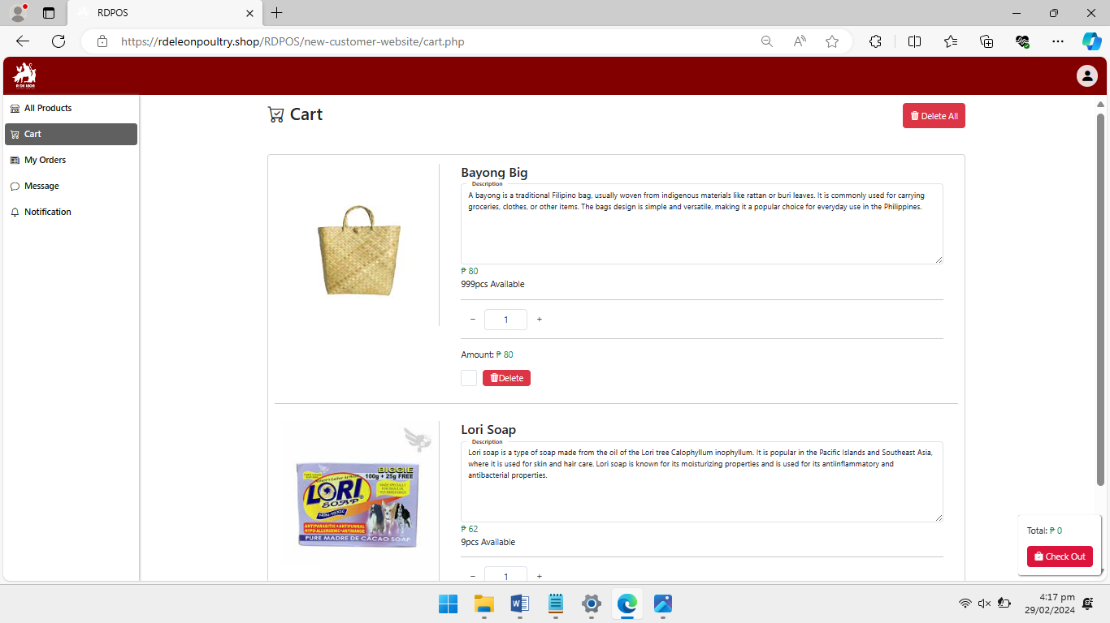

**Figure 17: Cart Page**

Display the cart contents for user review.

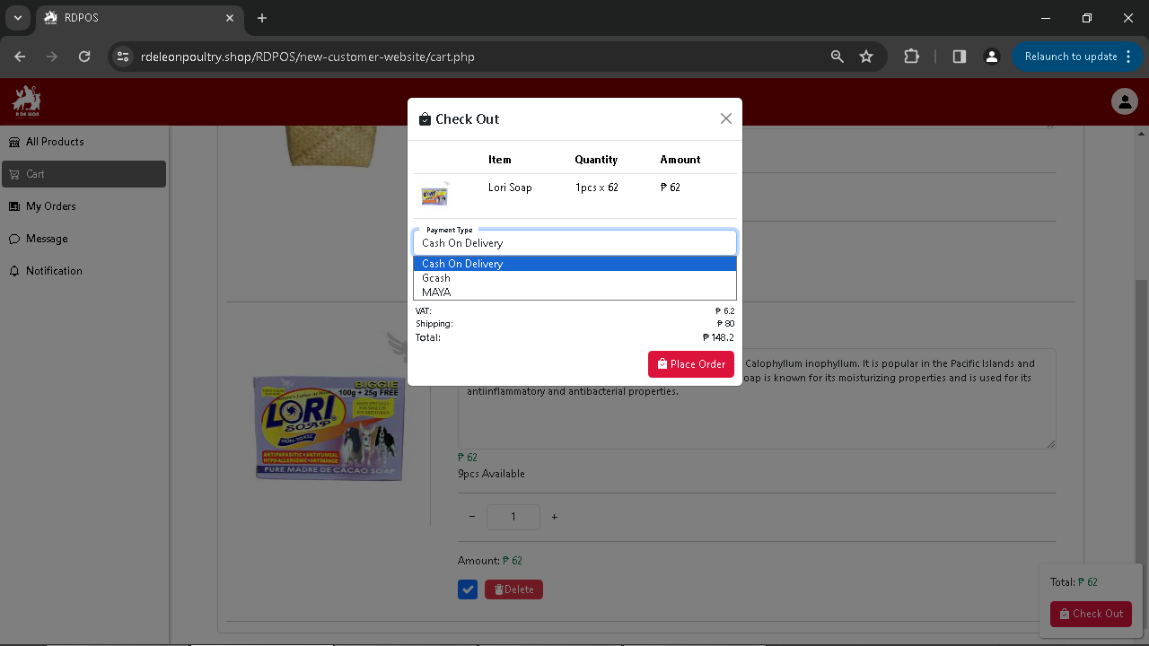

**Figure 18: Selecting Payment Method page**

Page for selecting preferred payment method.

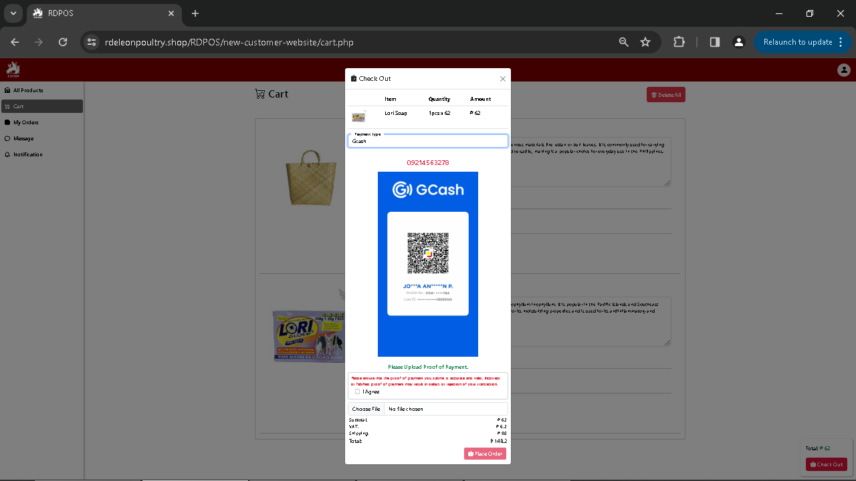

**Figure 19: Proof of Payment**

Display proof of payment confirmation.

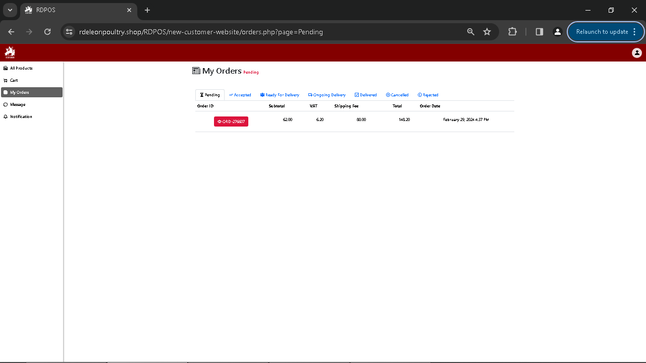

**Figure 20: My Orders Page in Customer**

Show user's order history.

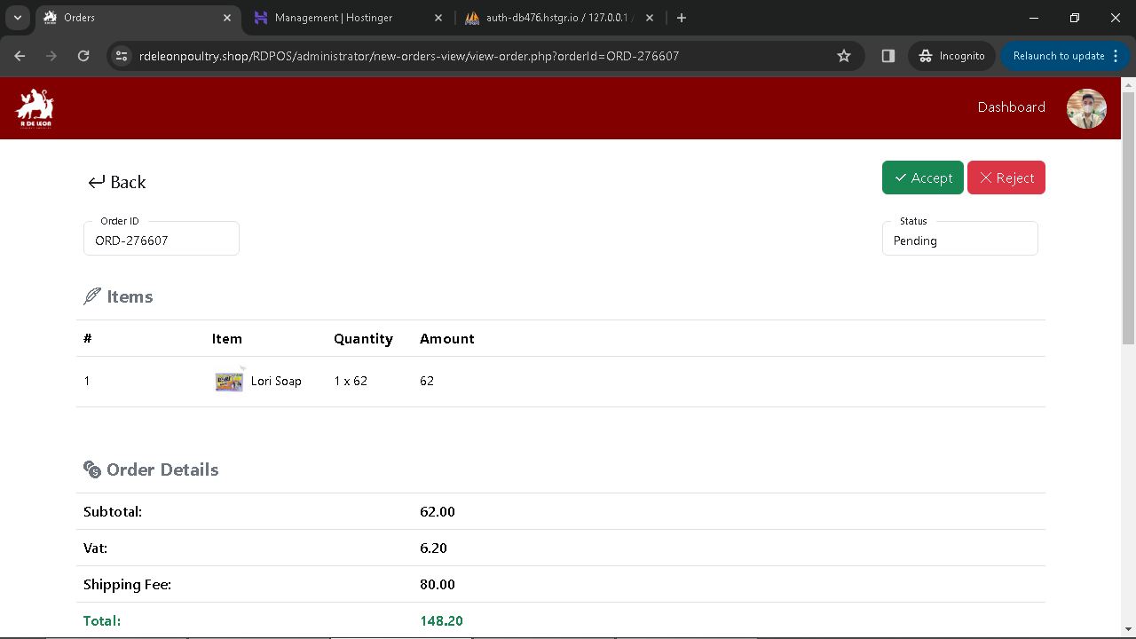

**Figure 21: Administration Order Validation**

Validation process for administration orders.

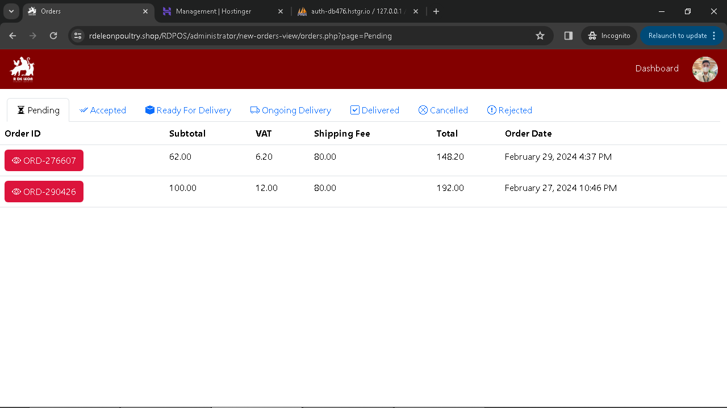

**Figure 22: Administrator Orders list**

List of orders for administrators to manage.

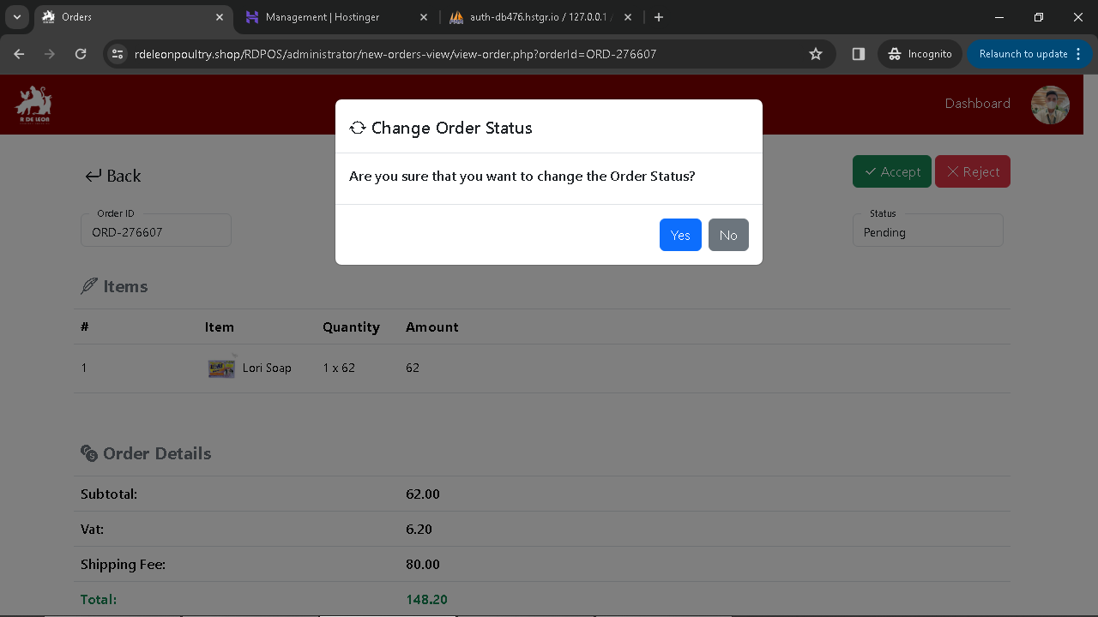

**Figure 23: Order Acceptance Validation Order**

Validate order acceptance status.

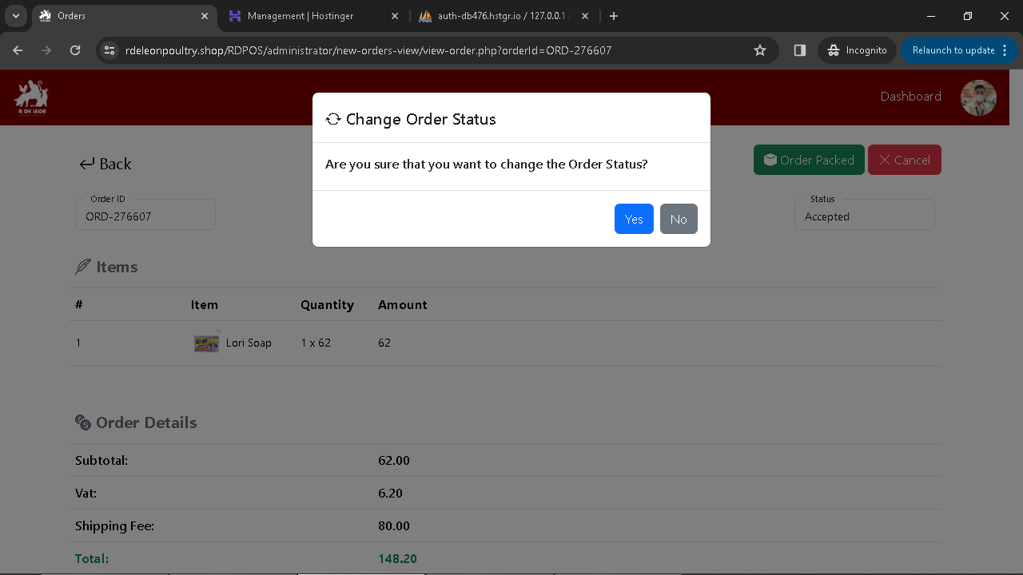

**Figure 24: Order Acceptance Validation for Order Packed**

Validate order packing status.

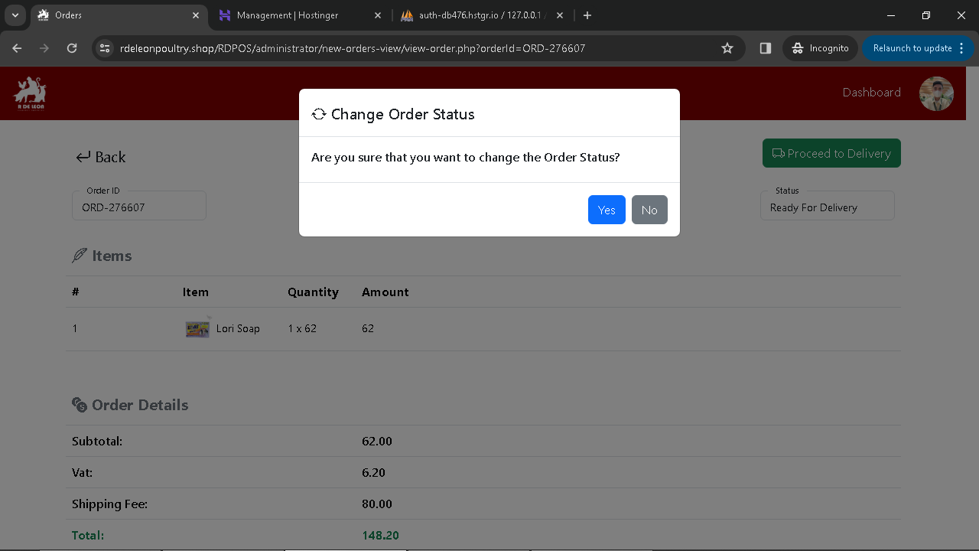

**Figure 25: Order Acceptance Validation for Proceed to Delivery**

Validate order readiness for delivery.

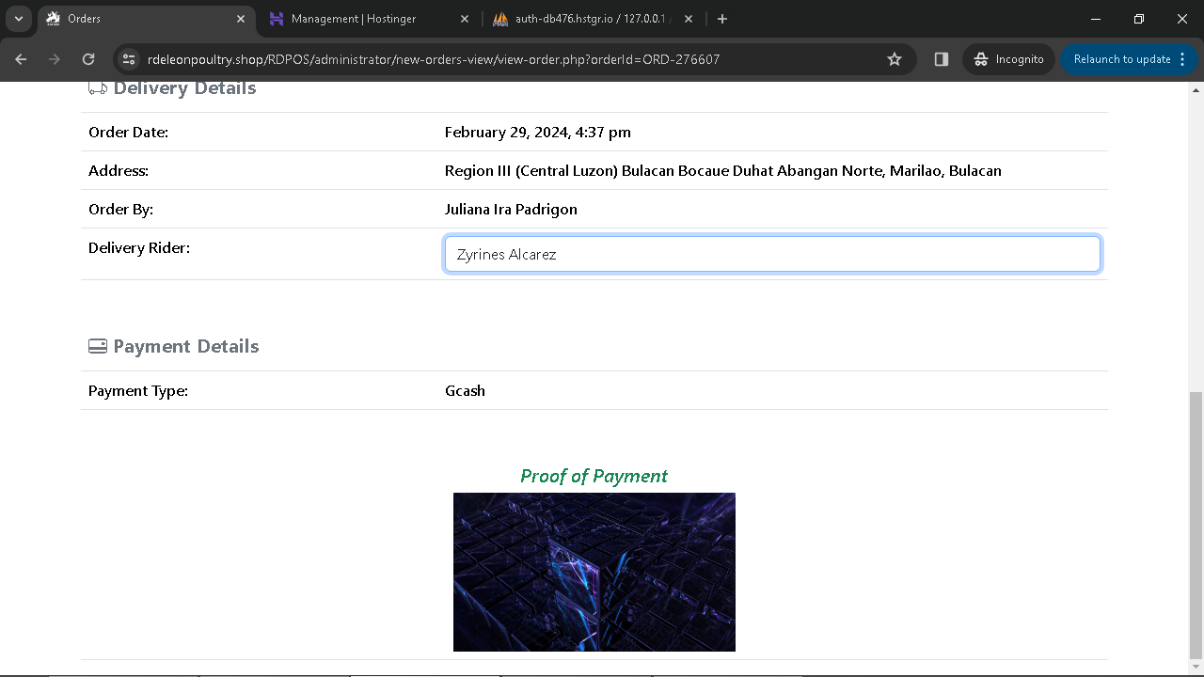

**Figure 26: Delivery Rider Selection Page**

Page for selecting delivery rider.

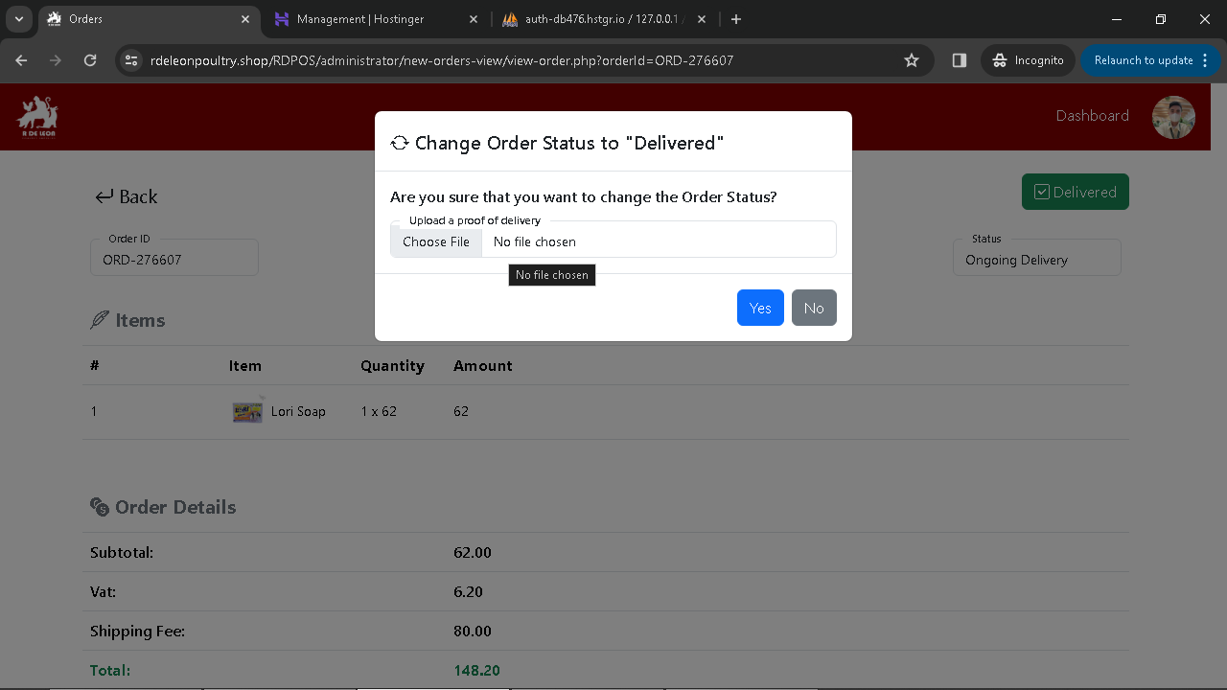

**Figure 27: Delivery Received Status**

Status update indicating delivery received.

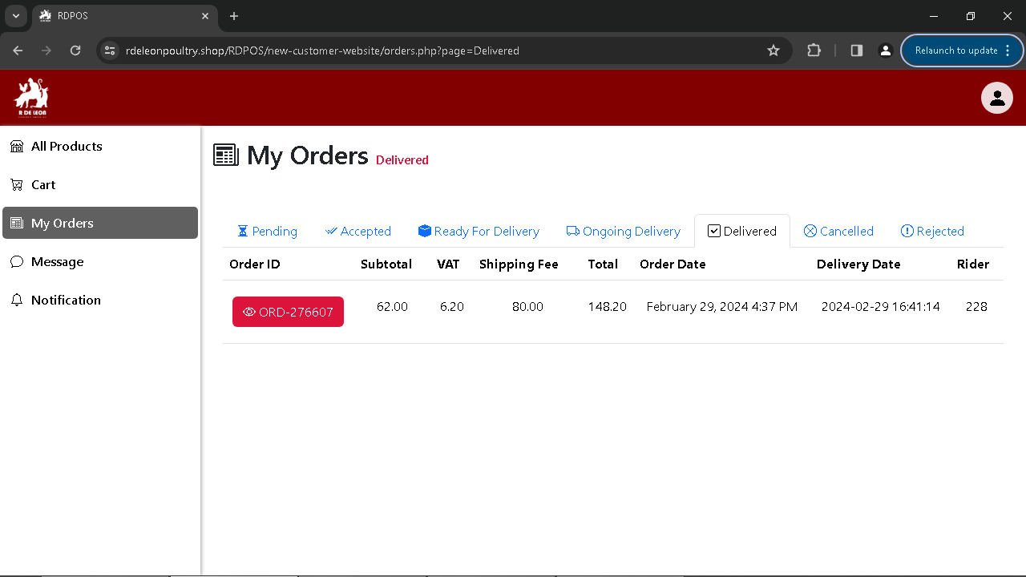

**Figure 28: Order Received**

Notification for order received.

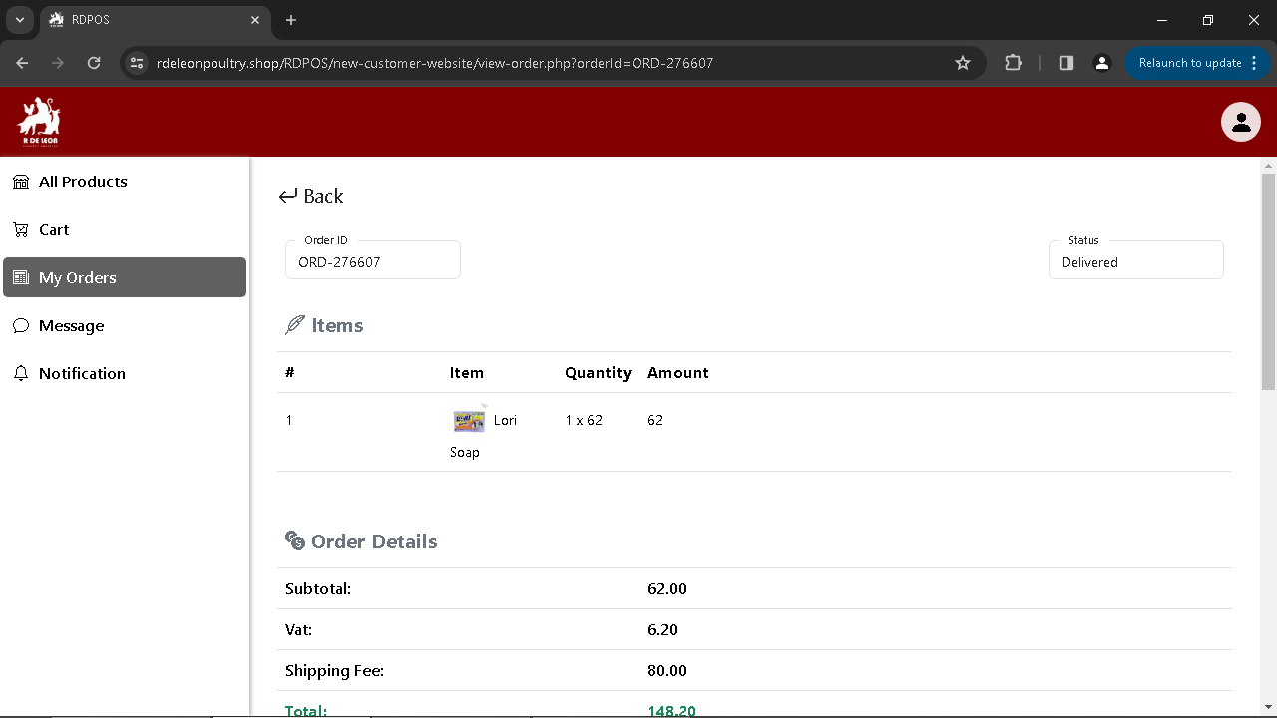

**Figure 29: View Order Received**

Detailed view of received orders.

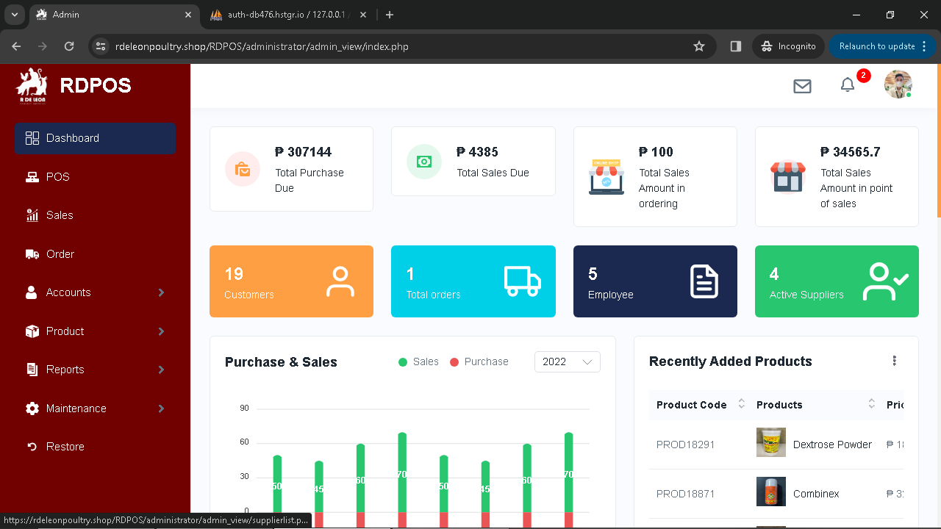

**Figure 30: Dashboard Page**

Dashboard overview for users/administrators.

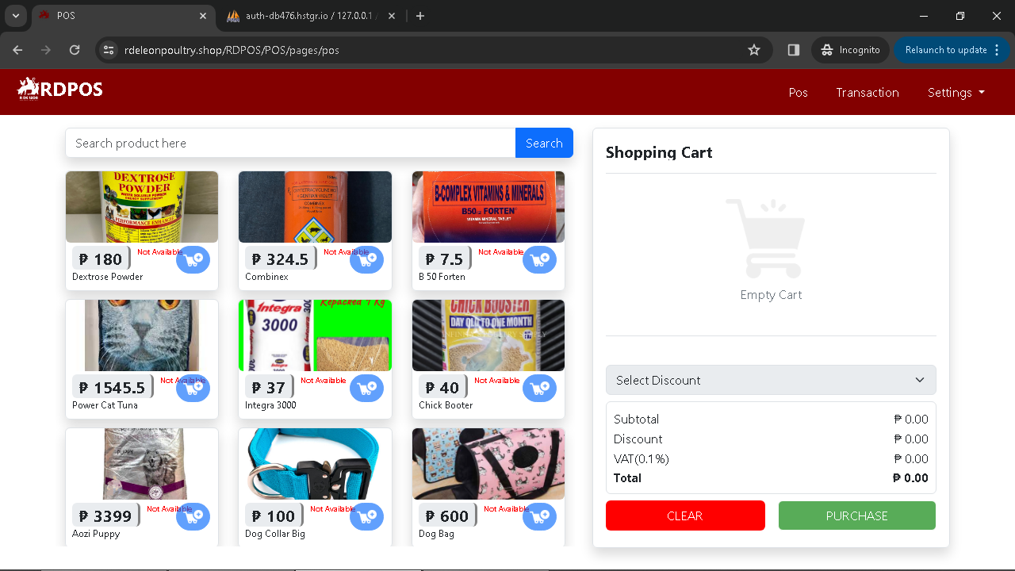

**Figure 31: POS Section Page**

Section dedicated to Point of Sale transactions.

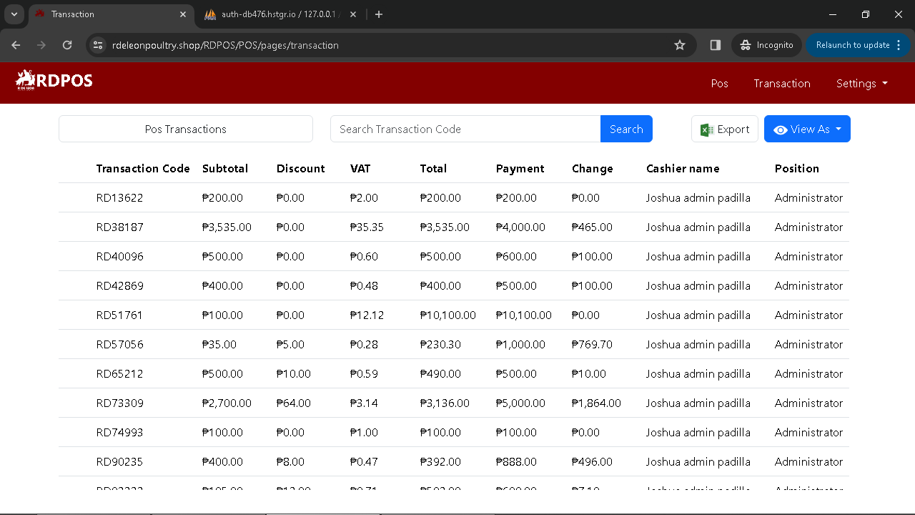

**Figure 32: POS Transactions Page**

Detailed view of Point of Sale transactions.

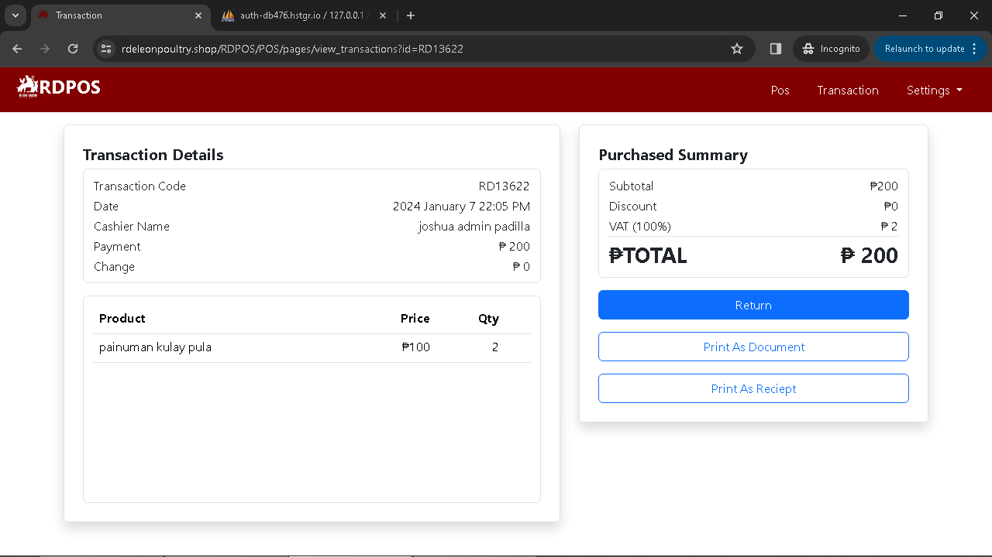

**Figure 33: View POS Orders**

Display list of Point of Sale orders.

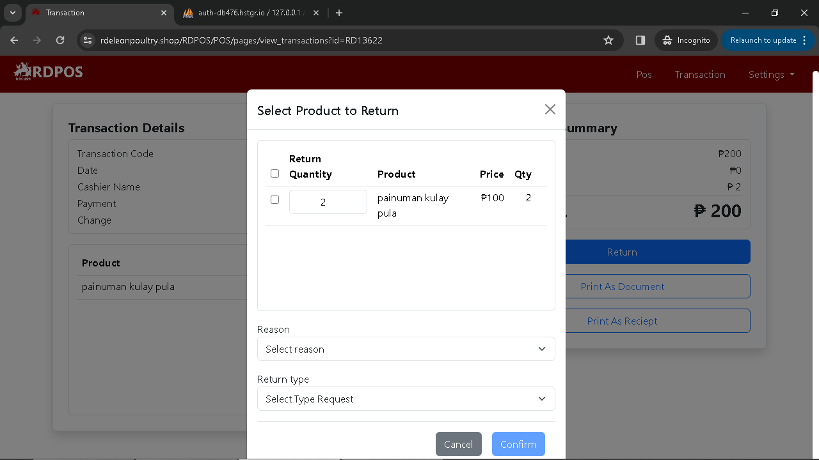

**Figure 34: Return Items Page**

Page for initiating item returns.

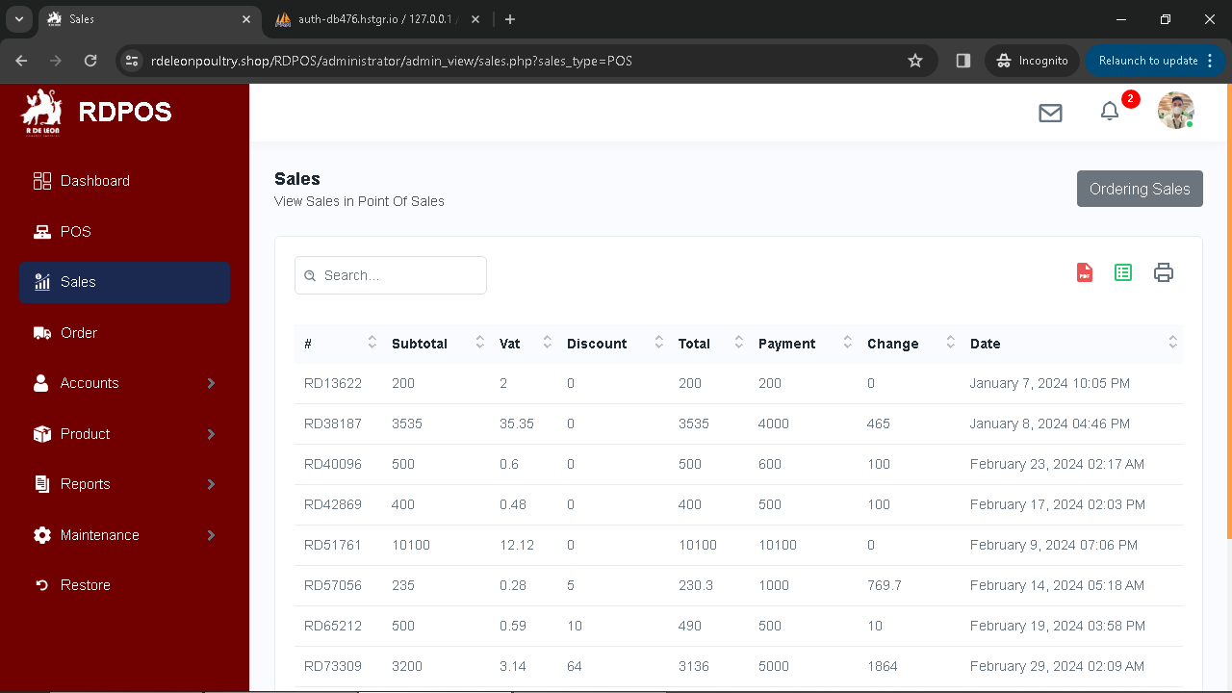

**Figure 35: Administrator Sales Page**

Summary page for administrator sales.

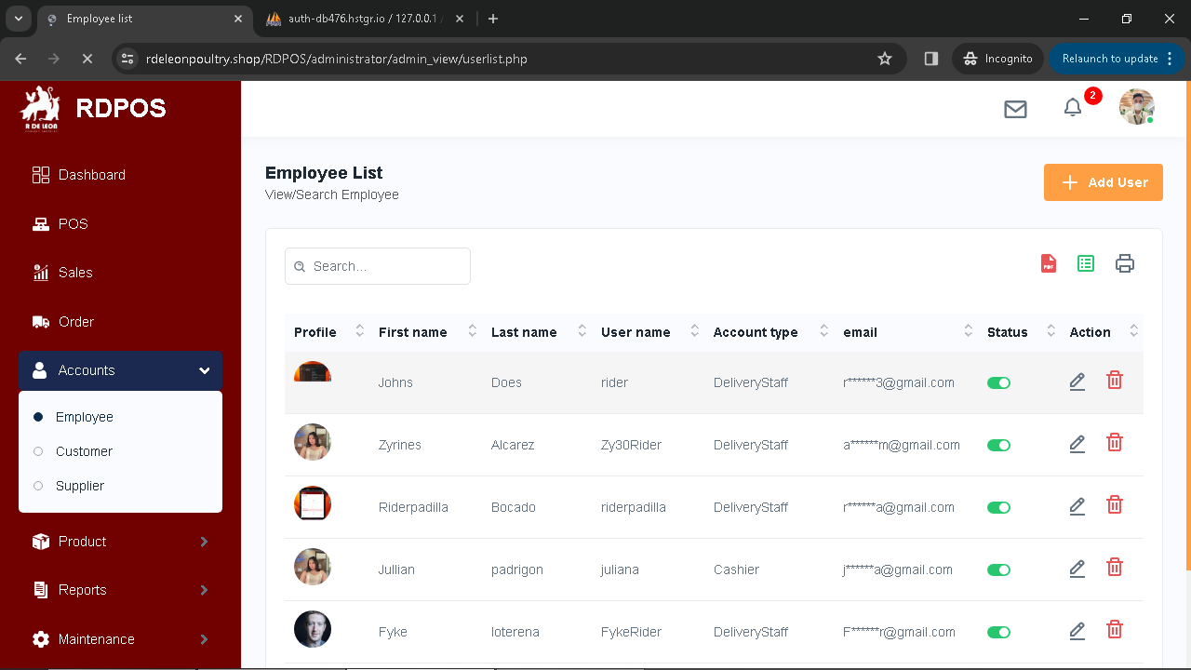

**Figure 36: Account List Page**

List of user accounts.

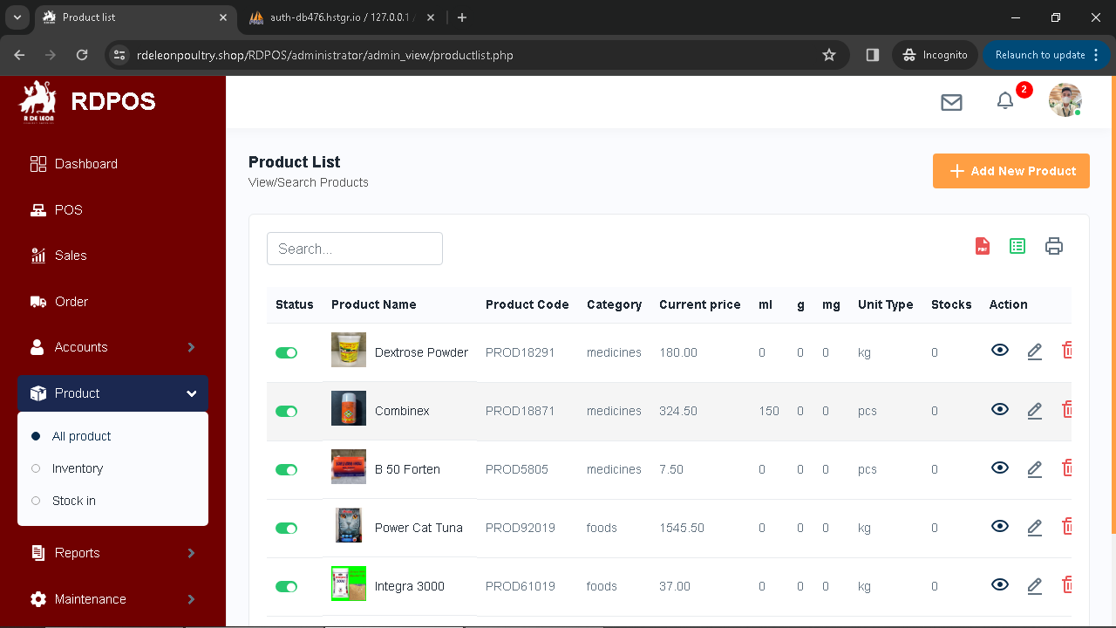

**Figure 37: View Product List Page**

Detailed view of product listings.

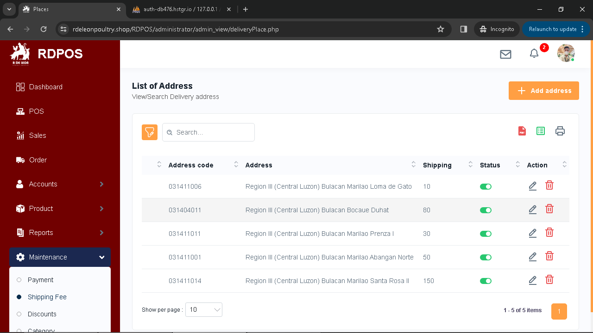

**Figure 38: View Shipping Fee Settings**

Configuration settings for shipping fees.

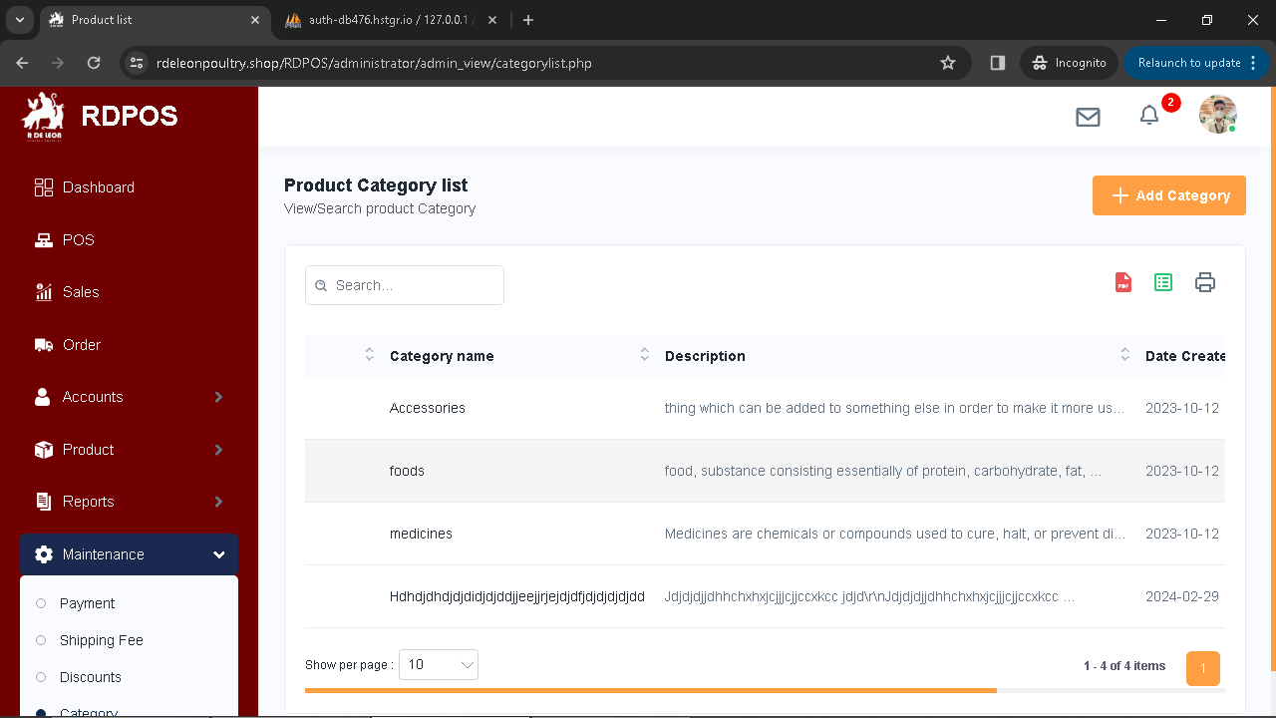

**Figure 39: View Order Received**

Detailed view of received orders.

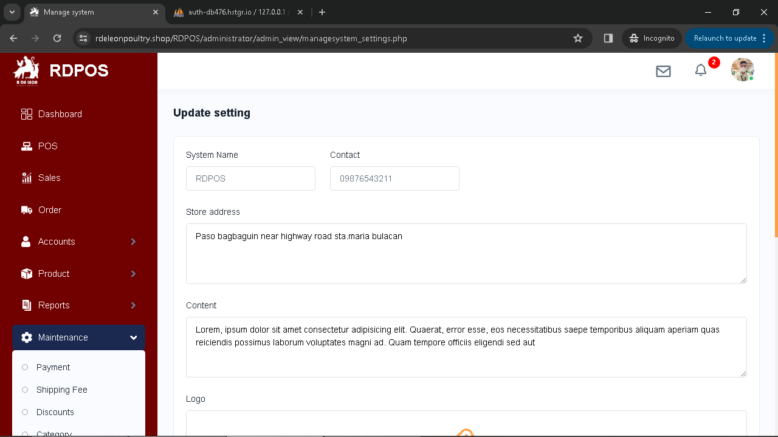

**Figure 40: View Order Received**

Detailed view of received orders.

**3.4 Project Development**

The data dictionary shows all the tables in the database of the system Online Ordering and Billing System with Point of Sales for R De Leon Poultry Supplies

*3.4.1 Software Development Model*

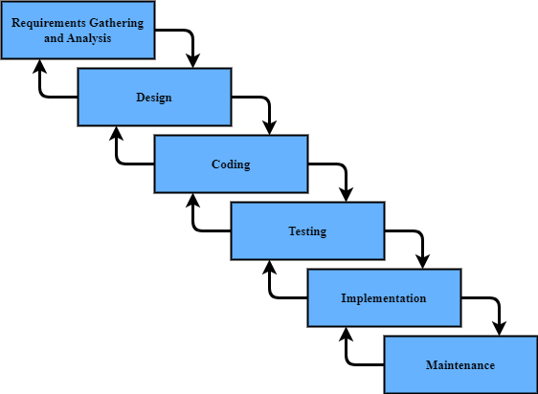

The Modified Waterfall model includes the following steps:

**Requirements** - The proponents gathered the necessary information from the business, and conducted an online interview with the client about the business processes encountered, and the traditional system of online ordering. also collect supporting documents provided by customers, which can help proponents meet the required requirements.

**Analysis** – After the proponents collect data, based on the interview the proponent may use it to think of a computer-based solution to resolve the conflict encountered. The proponents planned the process from ordering to billing and delivery. The proponents also designed and structured the database. After normalizing the database, the proponents designed a modular interface.

**Design** – The Proponents develop the system after collecting and analyzing all the needs and specifications for the previous phase. This serves as the phase in which diagrams are created and processed to form the system foundation. will develop a web-based system that has a user-friendly interface that will enhance the ordering system for the customer, will enhance the functionality of the delivery, can manage the products, accounts, and delivery with an administrator, and to have a convenient transaction with the cashier.

**Coding** – The proponent used Visual Studio Code 1.77.3 version, for the text editor that we used. The proponent also prefers PHP, Java Script, Html, CSS, Nice page, and Bootstrap to build and write the proposed system.

**Testing** - The proponents will use alpha, unit, integration, system, and beta testing to verify system functionality. The system was also verified by end users to check its functionality.

**Implementation** – The proponents evaluated the system and identified areas that needed improvement using iso 9126-1. They then incorporated the necessary suggestions from the end users and implemented them to enhance the system's functionality.

**Maintenance** – The proponents assure that the system has maintenance functionality that will continuously maintain the system for R De Leon Poultry Supplies. For the benefit of the business and its staff in the future, the proponents created a system that is easy to maintain.

*3.4.2 Software Requirements*

The necessary software prerequisites for the development of "RDPOS: Online Ordering and Billing with Point of Sales for R De Leon Poultry Supplies" are essential to enable the proposed system's functionality. These required specifications include:

* Windows 7, 8, 10
* Microsoft Edge Version 113.0.1774.50
* Google Chrome Version 114.0.5735.106
* Mozilla Firefox Version 114.0
* Visual Studio Code Version 1.78.2
* Hypertext Preprocessor Version 8.1.17
* Xammp Version 8.2.4
* Hostinger Version 8.1

*3.4.3 Hardware Requirements*

The system's involved specific hardware requirements, which were utilized in its development. These includes:

* Laptop / Desktop
* Processor: (at least 2.0 GHz) Intel Core i5 or i7
* RAM: 8gb or more
* Storage: Minimum of 256gb
* Barcode Scanner (Xprinter XP-7600)
* Thermal Printer (Xprinter XP-58IIH)

*3.4.4 Network Requirements*

The following requirements is needed for the network in developing the system:

* Internet (at least 3mbps)
* Web Hosting and Domain

**3.5 Project Testing**

The proponents will conduct testing procedures to test the correctness and quality of the system. These testing procedures include alpha and beta testing.

To verify that the system's website is fully functional and to look for any potential faults or errors, the proponents employed alpha testing. The proponents provide testing forms, which are alpha testing, and occasionally conduct this type of testing. Even though the system is not yet complete, the proponents conducted testing to take some suggestions and criticisms and determine what must be changed about the system. The proponents tested it each week to look for updates and modifications. According to the findings of the testing carried out by the proponents, certain features are functional while others are not, so the proponents must improve the other system features.

The proponents conducted beta testing for the end users. The proponents provide testing forms for the end users. It was done by the end users to check if all the requirements of the system were obtained and if the system is working. The end users give some suggestions and feedback that needs to be improved in the system. With the help of their suggestions and feedback the proponents have enhanced the other features of the system.

**3.6 Evaluation Procedure**

The proponents conducted a system evaluation for online ordering and billing system with a point of sale for R De Leon Poultry Supplies. to see if the system will provide the system requirements and specification. The proponents used ISO 9126-1 as the software quality model. It covered functionality, reliability, usability, efficiency, maintainability, and portability. In the evaluation the proponents provided an evaluation form to the evaluator. The form contains criteria and sub criteria in which the descriptions were aligned on the chosen software quality model of the proponents.

The proponents had the system evaluated by IT experts and end users. Evaluation was done for the enhancement of the system and for the identification of the errors in the system. In the evaluation process, the evaluators rated the system based on the given criteria. Furthermore, to get the sum of responses the Likert scale is used for the scoring of the system using the Likert items: Strong Agree, Agree, Partially Agree, Disagree, and Strongly Disagree.

**Table 25: Rating Scale Criteria**

|  |  |
| --- | --- |
| **Mean Value** | **Descriptive Rating** |
| 4.50 – 5.00 | Strong Agree |
| 3.50 – 4.49 | Agree |
| 2.50 – 3.49 | Partially Agree |
| 1.50 – 2.49 | Disagree |
| 1.0 – 1.49 | Strong Disagree |

The system and website evaluators were given an evaluation instrument during the evaluation procedure. The proponents presented and explained the functionalities of the system and the website. In addition, the proponents demonstrated how to use the system to the end users. After showing how the system works the evaluator rated the design and the website using the evaluation form.

**References:**

[1] Affiliation, I. (2020) Online Ordering Systems, Online Ordering Systems-Background information. Available at: https://www.coursehero.com/file/73535235/Online-Ordering-Systems-Background-informationdocx.

[2] Bacinger, T. (2015) What is bootstrap? effortless responsive sites with Bootstrap Web Development: Toptal®, Toptal Engineering Blog. Available at: https://www.toptal.com/bootstrap/what-is-bootstrap-responsive-sites.

[3] Barisal, S.K. et al. (2019) Validating object-oriented software at design phase by achieving MC/DC - International Journal of System Assurance Engineering and Management, SpringerLink. Available at: https://link.springer.com/article/10.1007/s13198-019-00815-8.

[4] CDW Expert (2022) What is a thermal printer and how does it work? CDW.com. Available at: <https://www.cdw.com/content/cdw/en/articles/hardware/what-is-a-thermal-printer-how-does-it-work.html>.

[5] Chanda, Dr.A. (2020) Barcode Technology and its application in libraries, SSRN. Available at: <https://papers.ssrn.com/sol3/papers.cfm?abstract_id=3649957>.

[6] Eggspert, T. (2023) Hostinger Review - the good and bad for 2023, The Daily Egg. Available at: https://www.crazyegg.com/blog/hostinger-review/.

[7] Fatonah1, S., Yulandari1, A. and Wibowo1, F.W. (2018) IOPscience, Journal of Physics: Conference Series. Available at: https://iopscience.iop.org/article/10.1088/1742-6596/1140/1/012033.

[8] Fisher, T. (2021) What is a router (residential gateway) and how does it work? Lifewire.

Available at: https://www.lifewire.com/what-is-a-router-2618162.

[9] Gowtham, S. (2023) Billing: What is it, types, process, how it works, Format & Software, Happay. Available at: https://happay.com/blog/billing/#:~:text=Billing%20refers%20to%20the%20process,payment%20from%20customers%20or%20clients.

[10] Gursoy, G. (2020) Full article: Effects of COVID-19 pandemic on the hospitality industry. Available at: https://www.tandfonline.com/doi/full/10.1080/19368623.2020.1788231.

[11] Ignacio, A.E., Buenaventura, R.U. and Laspoña, J.A.S. (2021) Mobile ordering application for a generic fast-food restaurant, International Journal of Multidisciplinary: Applied Business and Education Research. Available at: https://ejournals.ph/article.php?id=16818.

[12] James, R. (2020) What is Microsoft Edge: Everything you need to know about Microsoft’s latest web browser, Business Insider. Available at: https://www.businessinsider.com/guides/tech/what-is-microsoft-edge.

[13] Johnson, J. (2023) The Best Pos Systems for 2023, Business News Daily. Available at: https://www.businessnewsdaily.com/2955-best-pos-systems.html.

[14] Kenton, W. (2023) What is inventory? definition, types, and examples, Investopedia. Available at: https://www.investopedia.com/terms/i/inventory.asp.

[15] Khan, I.A. and Kumari, Dr. D. (2021) The role of the analysis phase of SDLC for small scale business application- A Review, INTERNATIONAL JOURNAL OF HUMANITIES, ENGINEERING, SCIENCE AND MANAGEMENT. Available at: https://journal.rkdfuniversity.org/index.php/ijhesm/article/view/82.

[16] Kokoris, G. (2018) What is order management? IBM. Available at: https://www.ibm.com/topics/order-management.

[17] Kumar, A., Baswaraju, S. and Kumar, I. (2020) Researchgate | find and share research, Implementation of Improved Billing System. Available at: https://www.researchgate.net/publication/345776202_Implementation_of_Improved_Billing_System.

[18] Lutkevich, B. and Lewis, S. (2022) What is the waterfall model? - definition and guide, Software Quality. Available at: https://www.techtarget.com/searchsoftwarequality/definition/waterfall-model.

[19] Muthuselvan, S., Somasundaram, K. and Rajaprakash, S. (2020) Preference findings for coding phase in software ... - IEEE explore, IEEE. Available at: https://ieeexplore.ieee.org/document/9074339/.

[20] National Restaurant Association releases 2020 State of the Restaurant Industry Report (2020) NRA. Available at: https://restaurant.org/research-and-media/media/press-releases/national-restaurant-association-releases-2020-state-of-the-restaurant-industry-report/.

[21] NetSuite.com (2022) What is order management? The Ultimate Guide, Oracle NetSuite. Available at: https://www.netsuite.com/portal/resource/articles/erp/order-management.shtml.

[22] Quiambao, J.L. and Alvaro, K.N.G. (2023) Impact of quality management system practices on the business performance of a government corporation in Clark Freeport Zone, Philippines, International Journal of Multidisciplinary: Applied Business and Education Research. Available at: https://ejournals.ph/article.php?id=19265.

[23] R. Blair, et al. (2018) United States Patent, AUTOMATED POINT OF SALE SYSTEM. Available at: https://patentimages.storage.googleapis.com/aa/ec/75/4cb75ab4db82bb/US20180096566A1.pdf.

[24] Raut, S. et al. (2020) Commercially and medicinally significant aquatic macrophytes: Potential for improving livelihood security of indigenous communities in northern Bihar, India, Journal of Threatened Taxa. Available at : https://doi.org/10.11609/jott.5640.12.13.16819-16830.

[25] Rosa, H.R.D. and Separa, L.A.C. (2022) Satisfactions of customers by using online food application services during COVID-19 pandemic, International Journal of Multidisciplinary: Applied Business and Education Research. Available at: https://ejournals.ph/article.php?id=18362.

[26] Rouse, M. (2020) What is a website? - definition from Techopedia, What Does Website Mean? Available at: https://www.techopedia.com/definition/5411/website.

[27] Singla, L. (2023) What is PHP for web development and why should you use it? Insights - Web and Mobile Development Services and Solutions. Available at: https://www.netsolutions.com/insights/what-is-php/.

[28] Talend (2023) What is MySQL? everything you need to know, Talend. Available at: https://www.talend.com/resources/what-is-mysql/.

[29] W3C (2023) Web standards, W3C. Available at: https://www.w3.org/standards/webdesign/htmlcss.

[30] What is windows? (2023) Computer Hope. Available at: https://www.computerhope.com/jargon/w/windows.htm.

[31] Whitehead, C.T. (2022) What is a LAN (Local Area Network)? Lifewire. Available at: https://www.lifewire.com/what-is-lan-4684071.

[32] Williams, N. and Nanthagopan, Y. (2021) Ares: An agile requirements specification process for regulated ..., world scientific. Available at: https://www.worldscientific.com/doi/abs/10.1142/S021819401950044X.

[33] Wilson, T.V. and Valdes, R. (2021) How laptops work, HowStuffWorks. Available at: https://computer.howstuffworks.com/laptop.htm.